Accra, Ghana, 10-12 November 2009

West Africa Regional Sanitation and Hygiene Symposium

CSOs sanitation & hygiene advocacy & awareness interventions in post conflict Liberia

Author: Mr. Prince D. Kreplah, [Liberia]
Introduction:
Liberia’s Poverty Reduction Strategy (PRS) estimates that ‘only 25 percent of Liberians having access to safe drinking water and just 14 percent having access to human waste collection and disposal facilities.’ Coverage varies from county to county for sanitation from 9% to 25%. Poverty is high at 63.8 percent implying that 1.7 million Liberians out of a population of slightly over 3.5 million are living below a dollar/day. Unemployment remains at over 80%, and similar proportions lack access to basic health, education, and other essential services. The Human Development Report of 2006 reveals how far Liberia lags behind the MDGs and suggests that, in the best-case scenario, only half of the goals could potentially be achieved by 2015, and none in the health sector or water/sanitation sector.

The need for Civil Society advocacy to influence policy on both government and donors’ side is key. Efforts around Civil Society mobilization in Liberia can make significant contributions to the current wider civil society campaigns on poverty in general.

Activities:
The Liberia Civil Society Organizations Water, Sanitation and Hygiene Working Group conducted the following activities as shown below:

Five Public Water Sanitation and Hygiene Forums: Each of the forums had fifty (50) participants’ drawn from civil society, communities, national and local government authorities and INGOs. During the forums in Monrovia two persons presented on separate topics while in rural counties the county health team served as resource persons. After each presentation, questions and answers were allowed. A video documentary done by the Liberia WaSH Consortium comprising of Action Contre LA FAIM, Oxfam GB, Solidarites, Tearfund, concern Worldwide titled “Liquid Liberia, State of water, sanitation and hygiene in Liberia” was screen to participants. The forums created the space for information sharing and awareness raising among community dwellers and civil society as means of influencing behavior change and promoting the involvement of more civil society in advocacy that influence the input and approval of Liberia’s policies on WaSH;

One mobilization event on Global Hands Washing Day: The event took placed in Kakata, Margibi County. One thousand four hundred (1400) community dwellers participated. During the indoor program the representatives of the county health team explained to participants’ method of prevention to water diseases and good sanitation and hygiene behaviour and practices. The video documentary produced by the Liberia WaSH Consortium was screen to participants. The event also had as one of aware strategy parade with matching band. The event endeavored to aware the participants about best hygiene and sanitation practices and ensure the opinions of civil society as well as community dwellers form part of the draft water, sanitation and hygiene policies before they are approved by the cabinet as a means of promoting national democratic ownership;

Four communities outreach on World Toilet Day: The activity took placed in Monrovia. One thousand one hundred participants attended. During the day’s participants were shown photos depicting the level of humiliation, risks, vulnerability associated with the human person especially the female when they sit in the open to toilet and urinate because of lack of latrine facility and how harmful it is to live in an unsanitary environment and level of risk associated with drinking unsafe water? The activities educated and raise awareness among the participants on sanitation and hygiene practice aim at influencing behavior change. They were taught about how devastating it is health while for one to return from the toilet and fail to wash his or her hands before eating or touching consumable substance. As a means of drawing public attention, the events were climaxed by a parade through the principal streets of Monrovia;

One mobilization and media campaign during the Global Week of Action against Poverty: The event mobilized five hundred (500) participants from Grand Bassa County. Three persons from civil society, government and development partners made promotional statements on water, sanitation and hygiene during the indoor program. Selected members of the CSOs WaSH Working Group who is well informed about WaSH appeared on radio and televisions as discussants alone with policy makers. Radio and television jingoes and promotional messages were aired in various local languages of project counties. The campaign raised awareness among community dwellers and civil society as well as deepen their understanding about best sanitation and hygiene practices, the final draft Water Supply and Sanitation policy and the National Integrated Water Resources Management Policy as a means of creating the space for them to involve in advocacy for their view to be included in these documents and for the government to finally approve the documents through the cabinet;

Lobby meetings with National Legislature, Ministers, CSOs and development partners: Five persons from members of the Liberia WaSH Working Group held meetings with law makers, ministers of government working on WaSH and selected relevant development partners. The ministries included ministry of lands minds and energy, ministry of health, ministry of public work, and the Liberia Water and Sewer corporation also met with were the house and senate’s committees heads on health, ways and means, etc while representatives of the International Monitory Fund (IMF), World Bank, African Development Bank (ADB) and Department for International Development (DFID). The delegation also met ten civil society organizations. During these meetings, one of the five persons said the objectives, raised the issues the visited persons needed to respond to, following which the stakeholder responded. After the response, visiting delegate members asked questions. Following each discussion, views of all parties were published in the media;

Three Pre G8 Civil Society dialogues: The dialogue converged 150 participants from civil society, government and donors. The video documentary done by the Liberia WaSH Consortium “Liquid Liberia, State of water, sanitation and hygiene in Liberia” was screened to participants. Three resource persons presented papers and the participants discussed issues raised in the presentations. Following presentations, participants were permitted to ask questions. Each dialogue went into group discussions, during which participants had the opportunity to exchange opinion on their feeling with respect to the presentations made by presenters and how their interventions can inform the statement. Each group had the opportunity to report back to plenary (the whole body) on what should constitute the recommendations from civil society. Plenary (the whole body) discussed each group presentation and derived recommendations from the issues raised in the presentations and other sources. Five selected participants were set up as a committee to draft the civil society position. Following the completion of the committee work, they presented to the body draft soft and hard copies. The body made inputs and adopted the position. The secretariat forwarded the position containing the recommendations, issues etc to the president of Liberia and G8 Nations Embassies in Monrovia and distributed to the print and electronic media.

Promotional, IEC and other materials: During the events flyers, posters, banners, and other IEC materials marked with promotional WaSH messages were distributed to participants. Selected events and activities derived informed recommendations coined in civil society organizations declaration reached at the end of each. Opinion of all stakeholders including the working group and the visited stakeholders were published in the print and electronic media and used to inform civil society advocacy position on WaSH. Some key policy messages used on promotional IEC, and other materials included “public toilets inadequacy demean millions of people dignity” “75% of Liberia’s population is vulnerable to water related diseases” “WaSH is the fulcrum of healthy community and people” “women especially suffered harassments as the result of sitting in the open to release themselves” “the erection of adequate toilet facilities will save our women from rape and other abuses” etc.

Broad Objectives:

The programs and activities broad objectives included the below:

Advocate to the Government of Liberia for Water, Sanitation and Hygiene policies which are developed in a participatory and are inclusive of the needs of the vulnerable and poor communities. This included advocating to government for;
- Appropriate budgetary allocations to meet basic human rights, needs of the WaSH aspects of the Poverty Reduction Strategy (2008-2011) and other poverty reduction instruments;
- Accountability and transparency to meet basic human rights on the use of resources including domestic and foreign assistance;
- Monitoring for disbursement, expenditures and sustainability.
Create donor interest to provide appropriate and adequate support to Liberia’s Poverty Reduction Strategy (PRS) in general and WaSH in particular.
- Aspects of aid effectiveness such as Harmonization, alignment, ownership, and mutual accountability will be included. This will promote the strengthening and use of government systems in delivering development aid.
To mobilize the local civil society and public opinion for increased support of WaSH focus and donor attention on Liberia’s WaSH sector. This also included
- Lobbying for CSO space for participation in government, donor and international processes relating to WaSH;
- Pursuing ways of enhancing networking among ourselves and with other groups and allies which are relevant to our work;
- Find means and support for increasing CSO Advocacy capacity for WaSH Advocacy.

Method/strategies:
The implementation of activities pursued the following strategies:

- Mobilization: We mobilized members of the public through group parade, public discussions during the forums, dialogues, outreaches on world toilet day etc. The public was sensitized on particular and respective topics relating to each objective.
- Lobby meetings: Lobby meetings with government, donor institutions and other relevant stakeholders was held with key figures in three sectors civil society, government and donors to raise the profile of WaSH as well as to discuss the policy implications of both government and donor policies;
- Media Engagement: the Working group used various media tools to reach out to different audiences, which include the government technocrats and donors. Media materials such as press statements, radio talk shows, radio drama etc were appropriately engaged for various topics;
- Publications and research: The working group researched on different topics in order to have informed positions and publicized the opinions of participants in the electronic and print media as a means of reaching out to government, donor and civil society;
- Work Plan: The working group developed a working plan, which had intervention logical frameworks with time frames and possible requirements.
Impacts:

The intervention made the following impacts:

- The profile of water, sanitation and hygiene was raised with government, donors and civil society;
- The intervention promote increase civil society understanding and advocacy on WaSH;
- Government officials, donors actors and civil society met face to face and shared experiences and pledged their respective commitment to dead with challenges facing the WaSH sector in the country;
- The space was created for the first time in Liberia for hundreds of CSOs opinion to be heard in the implementation, and formulation of policies and regulations on water, sanitation and hygiene;
- Hundreds of community dwellers, having been educated to best hygiene and sanitation behaviour, pledged to practice good behaviour and commit themselves to been fully engaged in activities and processes planed by the working group on WaSH.

Challenges:

The intervention even thou successful, but did not go with out challenges as shown below:

- More time was consumed on making presentations in rural communities than expected due to high illiteracy rate. Interpreters had to relay messages through local languages;
- Capacity of civil society on water, sanitation and hygiene advocacy, monitoring, governance, etc is low;
- Public perception on WaSH view the sector as government business as such attention is not too focus on debate around it like in the case of political issues;
- To have public officials from the WaSH sector attend activities on the sector was difficult due to basic schedule and for fear that civil society want to usurp their functions as will as due to unwillingness on the part of those officials to account for the sector budget support limitation for political reason;
- To access public policies/documents on WaSH was difficult because of lack of freedom of information act and due to weak public documentation centers/facilities;
- Lack of adequate WaSH data.

Lesson Learned:

During the implementation of the activities the following lesson were learned:

- Relevant Ministries And Public Corporation Intervening In The Wash Sector are themselves Eager For Robust Civil Society Advocacy And Awareness Programs to push cabinet and donors to act fast in financing the sector;
- The community dwellers and civil society are all eager to see a Liberia with improve water, sanitation and hygiene services, facilities and behaviour practice;
- There is huge WaSH aspect of the poverty reduction strategy funding gap of 87m and only 56.5m of 143.5m have been committed by government and donors;
- WaSH sector in Liberia is highly fragmented and lack coordination and monitoring mechanisms;
- The sector is under utilized, under funded and out of the country’s PRS and MDGs priority line;
- There had not been relevant CSOs intervention over the last one hundred plus years;

These lessons and challenges as stated above means there is lot for civil society in Liberia to do in terms of advocacy and awareness creation, there will be many ups and downs as CSOs intervene in the sector given the hostile environment, week capacity, inadequate funding support and wash data. With respect to achieving the country’s Poverty Reduction Strategy (PRS) and Millennium Development Goals (MDGs), there is strong need for CSOs to carryout robust WaSH policy and financing advocacy to donor and government for appropriate government budgetary support, policy formulation and implementation as well as donor aid to the sector in line with donor promise and government commitment to provide 70% and 30% respectively of the total cost of the PRS and world leaders promises made in 2000 to achieve the MDGs by 2015

Lesson to be learned by the Symposium:
- The symposium participants will learn that lots can be achieved in WaSH advocacy and awareness creation for behaviours change and increase funding to the sector using forums, dialogues, mass mobilization, lobby meetings, and outreach;
- That the media can be powerful tool to raise the profile of WaSH in our various countries;
- That increase civil society involvement in advocacy on WaSH issues is key and can help to accelerate progress;
- That information sharing and views exchanges between policy makers and community dwellers is relevant to the realization of national WaSH policies and plans.

Only about 39 percent of the Liberian population (1.37m people) has adequate means of human waste collection
Table 1. Poverty Reduction Strategy Priority Action Matrix
Government Priority Interventions | Planned Year | Plan Month | Responsible Agency
Rehabilitate 100 percent sewage system | 2010 | December | Liberia Water and Sawer Corporation,  Ministry of Health, Ministry of Public Works
Rehabilitate 3000 existing communal latrines in schools, hospitals and clinics | 2010 | December | Liberia Water and Sawer Corporation,  Ministry of Health, Ministry of Public Works
Assist families in the construction of 50,000 household latrines in rural communities | 2010 | December | Liberia Water and Sawer Corporation, and Ministry of Public Works
Construct 10,000 communal and institutional latrines in schools, health centers and public buildings | 2010 | December | Liberia Water and Sawer Corporation, and Ministry of Public Works
Establish 15-SanPlat Latrine Fabrication Centers and produce 50,000 slabs | 2010 | December | Liberia Water and Sawer Corporation, and Ministry of Public Works
Scale up hygiene promotion efforts in all 15 counties | 2010 | December | Ministry of Health

Operation of water and sanitation facilities is currently unsustainable.
Table 2. Poverty Reduction Strategy Priority Action Matrix
Government Priority Interventions | Planned Year | Plan Month | Responsible Agency
Develop and enact a national Solid Waste Management Strategy and Regulations | 2010 | December | Monrovia City corporation, the National Legislature and Ministry of Public Works
Support the strengthening and establishment of WATSAN committees and build their capacity through workshops and sensitizations | 2010 | December | Liberia Water and Sawer Corporation,  Ministry of Health, Ministry of Public Works

Figure formats
Figures include chart
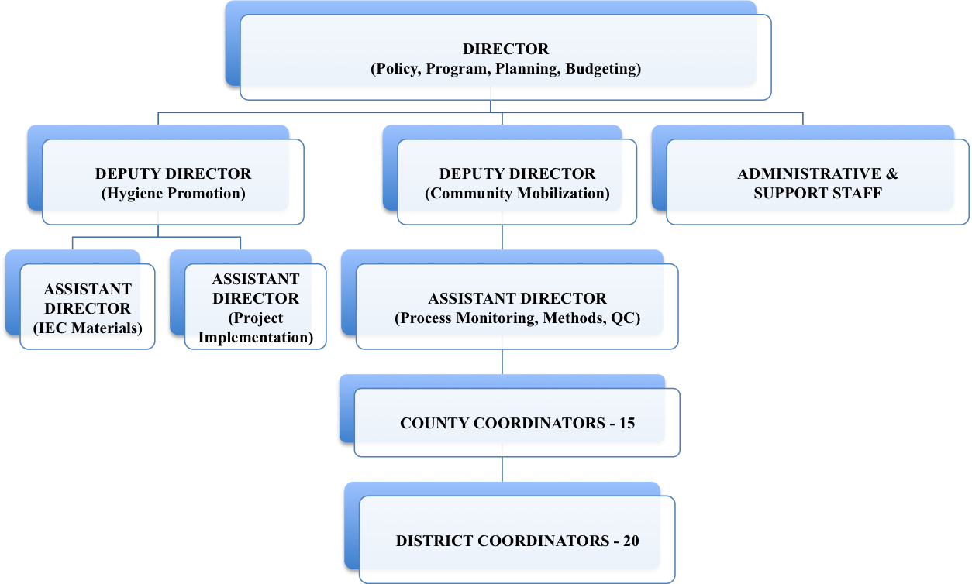
Figure 1. Wedc - Figure Title: Proposed Organizational Structure Of Directorate Of Community Mobilization And Hygiene Promotion (Dcmhyp)

Source: Water supply and Sanitation Policy

Photograph:
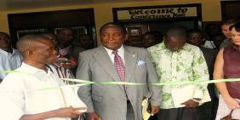 |  | 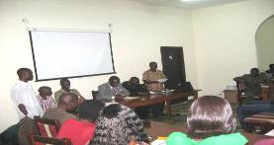
Photograph 1. Liberia’s Minister of Lands Minds & Energy prepare to cut ribbings |  | Photograph 2. Liberia’s Minister of Lands Minds & Energy presenting papers on WaSH at forum
Acknowledgements
This is a special appreciation to the Liberia CSOs WaSH Working Group including Association of Evangelicals of Liberia (AEL), Concerned Christian Community (CCC), Global Call to Action Against Poverty Liberia (GCAP - Liberia), Citizens United to Promote Peace and Democracy in Liberia (CUPPADL) and Women National NGOs Secretariat of Liberia (WONGOSOL) for their role in making this work possible. I will not be forgiven if I fail to appreciate the effort of the Liberia WaSH consortium and the Water Supply and Sanitation Collaborative Council (WSSCC) for funding the activities and programs.
References:
Liberia’s Poverty Reduction Strategy (PRS) 2008-2011 aim at realizing the Millennium Development Goals and the Ministry of Finance of Liberia Available at www.mofliberia.org/iprs.htm (Accessed 4, July 2009)

UNICEF Liberia Country WaSH Profile Available at www.unicef.org/28044.html (Accessed July 10, 2009)
Keywords
Interventions, Sanitation, Hygiene, Presentations, Commitment, mobilization
Contact details
Name of Principal Author Mr. Prince D. Kreplah  Address Broad Street, Monrovia, Liberia  Tel: +2316533015  Fax: N/A  Email: cuppadlinc@yahoo.com  www: N/A | Name of Second Author  Address  Tel:  Fax:  Email:  www:

