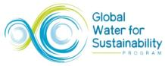
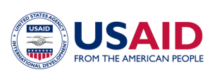

USAID West Africa Water Sanitation and Hygiene Program (USAID WA-WASH)

Report on the
Knowledge Management kick-off training workshop
2012, July 9 – 14, Ouagadougou
Performance Period: August 15, 2011 – September 30, 2012

August 2012
Contents
0. Introduction 2
1. The KM team 2
2. The training workshop program 3
3. Understanding WA-WASH / the WASH sector 5
Access to information 6
WA-WASH, GLOWS, KM and IRC 6
The KM Framework 7
The KM team 8
The WASH sector 9
4. Capacities 10
Blogging 11
Networking 12
Take stock of activities / keeping a calendar current 13
Facilitating discussions 14
Making video interviews / use audio and pictures 14
WA-WASH / WASH TimeLine 14
After Action Review (AAR) 15
5. Agreements 16
6. Next steps 18
A list of issues to look into now or later 18
The expectations versus the reflection on them 20
The SaGe group meets the WA-WASH KM team 21
7. References 21

Prepared by Jaap Pels, IRC, September 1, 2012
Peer review by the WA-WASH KM Team

0. Introduction
This report is made to describe what the kick-off training workshop of the WA-WASH KM team entailed, what environment the KM team is operating in and to write down the agreements made within the KM team. The latter is key for the KM team since they are supposed to ‘make information flow’ within WA-WASH.
The audience for this report is all WA-WASH staff; staff from Zinder to Miami and from Accra to Dori. All should be aware of how the KM team works, communicates, want to network and put in efforts to document the WA-WASH process as a basis to ‘make information flow’. On top of that all WA-WASH staff should grasp from this report where the KM team can help individual WA-WASH staff and support partner organizations to achieve the WA-WASH objectives.
The structure of this report is descriptive, starting at the KM team and the agenda made for the workshop, exploring the WASH and WA-WASH operating environment with various partners, two languages and four counties. The following chapters work towards the setting, capacity necessities, possible ICT setup and needed networking attitudes for a successful performance by the KM team.

1. The KM team
For the USAID funded and Florida International University (FIU) grant managed West Africa WASH (WA-WASH) program (http://www.globalwaters.net) IRC International Water and Sanitation (www.irc.nl) has the lead on the cross cutting knowledge management (KM) activities.

IRC contracted in the four WA-WASH countries local staff to manage the various KM activities on the ground. At first IRC made arrangements with Eau Vive – the Burkina Faso partner of IRC for projects such as WASHCost (www.washcost.info) and the IRC Francophone West Africa program. However, the change of management of Eau Vive also brought a change in cooperation between IRC and Eau Vive, resulting in Eau Vive pulling out from involving their Mali and Niger based offices.

IRC managed to establish working relations with SNV Niger and SNV Mali country offices (www.snvworld.org) resulting in a contract between IRC and SNV on KM activities for WA-WASH. Although WA-WASH Mali activities are suspended and partly also moved towards one of the other three countries, SNV Mali thought the KM work – especially the cross cutting and West Africa wide objectives of KM - of such importance and interest that they mandated a staff member to attend the workshop; also to be in synch the minute Mali activities start-up again.

For Burkina Faso and Ghana arrangements have been made by IRC with IRC Ghana and IRC Burkina Faso, the IRC branch offices in the respective countries. Officers for KM activities in the branch offices are dedicated to WA-WASH for an agreed percentage of their time. The KM team now consists of:
- Jaap Pels, Team leader, coach [IRC NL], pels@irc.nl, +31-619164195, jaap.pels@gmail.com
- Peter J Bury, Deputy lead, coach [IRC NL], bury@irc.nl, +39-3343296201, profbury@gmail.com
- Victor Otum, KM lead Ghana [IRC Ghana], otum@ircghana.org, +233 233768776 /+233244768776
- Ousmane Tiney, KM lead Niger [SNV Niger], otiney@snvworld.org, +49 4281 9525240
+227 94 01 02 40 otiney@snvworld.org
- Danséni Koné, KM lead Mali [SNV Mali], dkone@snvworld.org,
+223-76471062 / 66984626 dkone@snvworld.org
- Nourou-Dhine Salouka, KM lead Burkina [IRC BF], salouka@ircbf.org,
+226-76502712 nourdinesalouka@gmail.com

2. The training workshop program
As this was a KM team kick-off workshop and participants did not know each other, team building and levelling was vital. The program can be found on Google docs at: http://goo.gl/JX9tP. Of the objectives A through I (see table below), a good start and much progress has been made and / or the foundations are laid to build upon. The rest of FY1 will be used to get familiar with tools and methods and working as a KM team. The outputs listed are started and much of them have the spirit of ‘living documents’ or activities which need a certain degree of ‘continuous attention’.

In terms of KM, WA-WASH is at the early stage of stock tacking. Overview of ‘who planned what activity where’ is paramount next to getting hold of the coordinates (name, email, phone, organisation, country etc). The team made a start by population a contact database (see online section in the table below) and a country WA-WASH calendars. Both outputs need regular updating because of staff and planning changes. Both shape basic conditions for WA-WASH partners to be on top of what’s happening.

During the workshop and during the WA-WASH forum on capacity building the KM team members practiced with KM tools and methods. For example blogging and video taping an interview was practiced. During the forum KM team members (co-) facilitated the majority of the sessions and practicing skills like listing key discussion point in a break-out discussion group, conducting short interviews, creating a photo story, a Trombinoscope (a French language directory service publication) and reporting back in plenary.

Table 1: KM training workshop core blocks
Purpose: | Building blocks towards an efficient and effective KM team and KM component in WA-WASH
Objectives: | - Common understanding (a.k.a. alignment) on WA-WASH knowledge management context, purpose and approach;  - KM team building and spirit initiated and modalities for growth agreed and put in place;  - KM team and broader WA-WASH relevant communication, channels, methods and tools reviewed and practised;  - KM team process documentation skills enhanced through practice;  - KM team planning, management and monitoring tools developed;  - Broader WA-WASH setting; understand and work with the USAid WA setup / framings.  - Establish a good network and rapport between WA-WASH KM team members  - Well understanding the approach and the organization of KM Team  - To put in place (a) network(s): KM team; WA-WASH per country; WA-WASH overall; WA-WASH in the region.
Outputs: | - Inception workshop report (mostly drawings / pictures) describing, among others, agreed WA-WASH KM approach);  - Documentation of KM team principles of collaboration and team building methods;  - Documentation of communication channels, relevant guidance, and initial evidence of use by all participants;  - Participants contribution (process documentation) produced and published on relevant channels;  - WA-WASH KM final draft inception plan;  - Individual first blog post, first video interview;  - WA-WASH KM contact sheet http://goo.gl/2yFC1
Online: | WA-WASH KM documents on Drive shared with KM team members;  DropBox (WA-WASH documents platform?) - To show and keep when needed  Plugin for Microsoft office to sync with Drive? - How does this work?  Preferred set of (online) tools for WA-WASH KM team work:  - Chrome and related useful plug-ins and Google tools (e.g. URL shortened http://goo.gl/; translate http://translate.google.com/#)  - Google+ and our WA-WASHKM page there https://plus.google.com/b/107160653991534036000/107160653991534036000/posts  - Wordpress.org (GlobalWaters); later on use of Drupal application.  - Gmail or at least a Google account - Victor & Nourou-Dhine will be on GoogleApps; SNV staff Tiney - Niger and Danséni - Mali Google account with SNV email address  - Skype for direct communication / chat and later Twitter, Facebook, LinkedIn

The workshop was also attended by Elise Vollette who is an intern of Akvo (http://www.akvo.org).

On Friday the FIU Miami / GLOWS WA-WASH Program Executive Officer, WA-WASH Ku McMahan visited the training workshop and he received a first-hand reporting back on content, progress and outlook of the KM training workshop.
A full overview of presentations and back-ground materials: http://goo.gl/8DmMZ. Other pictures at: http://goo.gl/DBJPu and http://goo.gl/Z2mtk.

3. Understanding WA-WASH / the WASH sector
Within the worldwide KM for development community it is well understood and discussed that three dimensions are fundamental to practice KM. These three are power, access and language. The latter is obvious; the grant manager Florida International University (FIU) is US based. Both FIU and the WA-WASH donor USAid need reporting and will (de)brief in English.

Three out of the four countries are Francophone and their take on KM differs substantially form the Anglophone KM community. Various studies (Le Borgne 2011, WAWI 201 en Pels 2005) point out that knowledge sharing and information available in non-native language are a too big hurdle to take for most sector professionals, let alone the practitioners and benefices on the ground. Illiteracy is an issue too.

Access to information
Access has two dimensions. First and obvious is access to information; in the light of the above also in the right language. Build on this is the much used “KM adagio” “the right information to the right people at the right time”. However, this has to be complemented with “access to knowledge-able people”; in other words a network. It is paramount to engage all local WASH people in a network - probably based on language – to ensure “after project continuation” of efforts started by WA-WASH.

In any development project the issue of power is at stake. Sometime it is obvious because of the organizational hierarchies and sometime local customs and culture assign power to certain people. Power is a major obstacle for proper knowledge sharing. This means the circumstances for knowledge sharing must be designed such that power issues are played down. There is a hoist of tools and methods for knowledge sharing that address such. A good source is http://www.kstoolkit.org.

WA-WASH, GLOWS, KM and IRC
To get a good understanding of how the KM activities fit the USAid budget, Jaap Pels (IRC) told the story / shared his knowledge while sketching the below drawing. It explains the context of the WA-WASH program which is embedded in the GLOWS project which is a financial mechanism for USAid funding.

Picture 1: institutional embedding of KM in WA-WASH / GLOWS
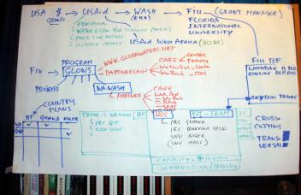

Knowledge Management is a regional and cross cutting activity in all four countries. The image A – taken from the PMP (Performance Management Plan) – shows the overall framework for WA-WASH.

Image A: The overall WA-WASH framework taken from the PMP
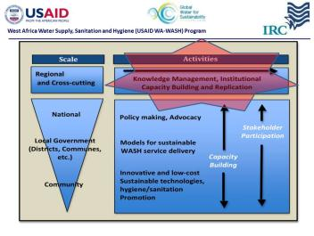

The KM Framework
More in detail (see image B below) KM entails facilitating learning and sharing through conversations / activities of WA-WASH and establishing a network of WASH in country staff. These processes have to be documented - in French “Capitalisation” – to be stored and made ready for communication / dissemination.
The management of information needs structural attention because WA-WASH does not want to work as a bundle of individuals or silos but in concerted action.

Image B: The KM framework
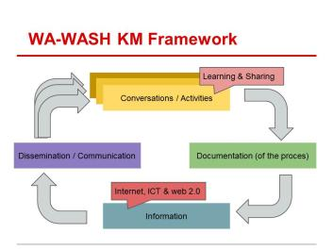
During the KM kick-off workshop a shared understanding of the WA-WASH program embedding in GLOWS and the roles / possibilities / responsibilities of the partners including the Burkina Faso based FIU office developed.

The KM team
The below image C and picture 2 were used to illustrate how the core KM team functions geographically and in the countries the KM officers live and work. Image C is taken from the WA-WASH PMP (Performance Management Plan) and shows how core KM team member have to network in country with the WA-WASH partners to form a “KM country team”. Picture 2 holds the key remark that the KM team is the “glue” when the “flow of information” (non-administrative!) and “knowledge sharing” is at hand. During the Capacity Building forum the KM team took the responsibility and opportunity to facilitate a number of discussions (conversations) like break out discussions on WA-WASH capacity building per country and activities to start harmonization calendars.

Image C: How the country KM teams link up
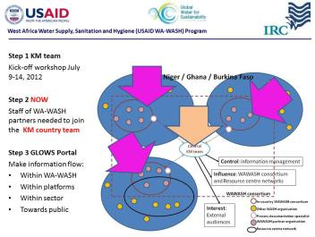

Picture 2: Geographical map of the core KM team
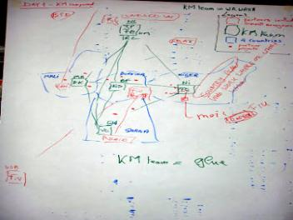
The next step for the KM team country members will be to establish working relationships with the WA-WASH partner in their respective countries.

The WASH sector
Pictures 3, 4 and 5 show the work done during the KM workshop on the WASH sector in Burkina Faso, Niger and Ghana. It is a first attempt to come to grips with the network of institutions and organizations active in the WASH sector. This exercise has a twofold purpose; first to take inventory of possible network members and list current platforms and initiative for knowledge sharing and secondly it is a first take on the audiences WA-WASH can address with finding and leanings. By sharing the individual sheets in plenary other participants will be inspired or get ideas for improving their understanding of WASH sector players and possible target groups.
Picture 3: A first take of the Burkina Faso WASH sector
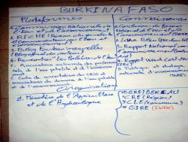
Picture 4: A first take of the Niger WASH sector
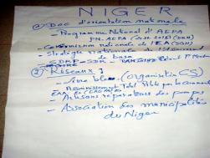
Picture 5: A first take of the Ghana WASH sector
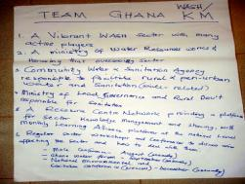
It turned out the above exercise preluded on an exercise during the capacity building (CB) forum. WA-WASH CB is in need of a similar overview; it is not the intention to start a new platform but harmonizing with existing platforms and coalitions of organizations for learning and sharing WASH lessons and knowledge.

4. Capacities
After understanding the setup and embedding of the WA-WASH project the KM team training workshop focused on aligning capacities using new technology for team- and virtual communication and documentation. The ground was prepared by making sure all KM team members had their computers tuned for Skype communication, using Chrome as a browser, working with Google Apps and Google cloud connect. In ‘Image B: The KM framework’ above the focus shifted from the top block (WA-WASH activities) towards the block on the right: ‘Documentation’ and reaching out to the bottom block ‘Information’.

Immediately the group experienced the connection problems in the WA-WASH countries. The applications to use must be light in terms of bandwidth consumption and preferably have functionalities for off-line working and synchronization. After all the necessary programs were downloaded and installed, capacities on the below issues were build.

Picture 6: Checking the browser / Skype / synchronization settings and practicing the use of the video camera
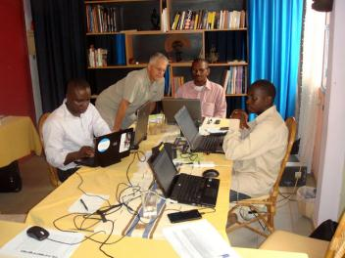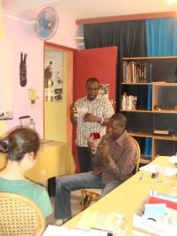

Blogging
In the project proposal it is mentioned the KM country staff will blog once a week on WA-WASH relevant issues. For this the KM team was trained in the use of the GLOWS instance of WordPress. A small manual was created; see: http://goo.gl/LiwfV. In the meantime the Ghana and Burkina Faso blog have been updated with a first post.

Screen dump I: The Burkina Faso and Ghana blog in the GLOWS portal
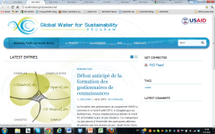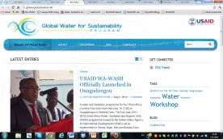

There are still a number of issues to address in respect to blogging. First the KM team members in country have to develop a habit of blogging weekly. Second they have to develop a writing style and third they will have to make a selection of the topics to blog about. Last, connectivity still remains an issue.

It is anticipated GLOWS will develop a portal which will be ready as of November 2012. FIU Miami will train the KM team on entering WA-WASH program data and files into that system. It was foreseen to combine the KM training workshop with the introduction training to the GLOWS system but the latter was postponed to Q1 FY2.

Networking
To succeed the KM country officers will have to network with WA-WASH partners in their respective countries and the wider WASH community. See also image 2 and picture C for graphical representation of a net. To start, connections will be made with country partners.

To start making information flow within the WA-WASH program teams, two email groups have been started and all WA-WASH staff is invited to the appropriate list:
  - WA-WASHKM@Googlegroups.com for the KM team + selected others
  - WA-WASH@Googlegroups.com for all WA-WASH staff.

Screen dump II: The WA-WASH mailing list on Internet
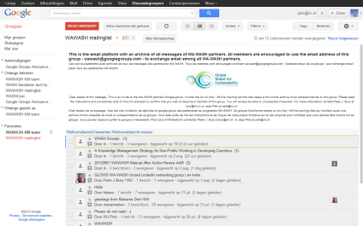

Next step will be to start collecting the coordinates of WA-WASH people in country and connecting with them, not in the least to help with taking stock of WA-WASH activities and to keep the calendars current.

Take stock of activities / keeping a calendar current
Up to now WA-WASH interfaced merely with paper based documents. For a program like WA-WASH and the context it is operating in such is not dynamic enough. The PMP and work plans are year / month based where real synergizing needs a daily up-to-date calendar of who is doing what activity where. That would open up opportunities for partners – and their implementers - to liaise when and where possible not in the least because the planning is dynamic and very much depending on uncontrollable / unpredictable circumstances.

Just to give an example: the Mole 13 conference in Ghana which is important for WA-WASH to be present was postponed because of the passing away of the Ghanaian president. But also other local practice, culture and circumstances need to be taken into account such as the administrative holiday in August, the Ramadan, the moths working in the Sahel is barely possible. Last it is known planning is moving at the last moment frequently. Only a current dynamic calendar will work.

Screen dump III: The public WA-WASH country calendars
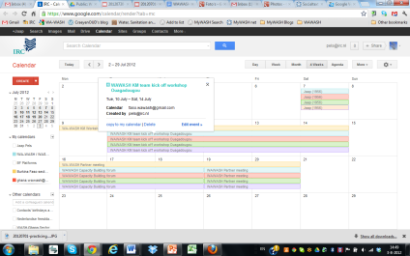

Another issue is the lack of a central place on Internet where all planned activities of WA-WASH are gathered. The mentioned GLOWS portal should offer a platform for that and the KM team suggested to use the open source AKVO RSR (Really Simple Reporting) functionality for this. See: http://washalliance.akvoapp.org/en or http://washalliance.akvoapp.org/fr for a French interface and click on an organization mentioned – like WA-WASH partner RAIN Foundation - to see the details. This system also holds possibilities to update / report on sustainability later on by means of spot checks and fact finding missions. The KM team will develop a budget for such an exercise.

Facilitating discussions
A KM team member will guide and facilitate the production of content material rather than create such themselves. For this it is needed to be able to facilitate a group of people. During the training / workshop a couple of dry runs were made for recap of lessons learned the day before or making a presentation of TimeLine (See below).

The proof of the pudding was taken during the July 2012 Capacity Building forum and the Partner meeting the week after the KM kick off workshop. During these events the KM team-members facilitated almost on a daily bases discussion groups and synthesized take-outs and consolidated conclusions plus presenting them in plenary. Next to skills this also needs some personality and they were clearly built during the course of the week.

Making video interviews / use audio and pictures
For various reasons the KM team will be documenting with audio, video and pictures. A first reason is speed. Report writing takes a lot of time for writing and peer review etc. By the time most reports are ready nobody is interested anymore because priorities have changed, people do not read or have no time for at or are illiterate / are not comfortable with English. So the second reason is access; text is not always easy accessible and it is said one picture says more than a thousand words.

As documentation of the KM kick off training workshop and of the CB forum a picture story is made by Tiney Ousmae and Peter Bury. As mentioned before Nourdine Salouka is working on a trombinoscope and pictures taken during the workshop, forum and partner meeting are available online. What was needed here was an agreement on where to store the digital materials. See the below chapter on agreements.

WA-WASH / WASH TimeLine
One way of coming to grips with the history but also with progress on a program timescale, using a TimeLine is a useful instrument. Below, the picture shows the practice-run TimeLine by Jaap Pels. It depicts his involvement in KM and the West Africa WASH sector.

Picture 7: Example of a (personal) TimeLine
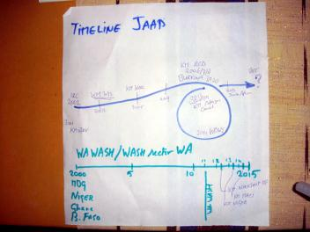

It is envisioned the KM country team members build a TimeLine over the length of the program asking key sector players and WA-WASH staff what indicates key moments of change for the WASH sector in their respective countries. Key moments will be the inauguration of a new policy or the start of a new program or perhaps the discovery of oil in the Ghana case leading to a more self-supporting WASH sector.

After Action Review (AAR)
When WA-WASH partner deploy activities in the field and / or in academia etc., it is of great importance a record is kept of what was planned, what happened and what was learned directly or shortly afterward. Reflection on what is learned is useless when the event under investigation is too long ago. In the meantime people have other priorities or interests and they may have changed jobs. Practical reason for using ARR is the fact that distances are big (and not always easy to travel), people are pressed for time and opportunities are few to get together face to face.

It is proposed all WA-WASH activities are completed with an after action review. This is a short session (30 minutes maximum) where facilitators and participants or implementers and benefices sit together and ask themselves the three above questions: what was planned? What happened? And what can we learn from this to improve our practice. The output is a short write-up indicating key (re)sources and people where more detailed information can be obtained on demand.

A manual and form for capturing learning After Action Review style has been made and can be downloaded here: http://goo.gl/SoENF.

All AARs in combination with the calendars, photo stories, video interviews and updates of the RSR system will build a legacy that will last after the WA-WASH program end.

5. Agreements
A key to the success of the KM team and the KM country teams is built upon solid way of communicating with each other and keeping each other in the loop. As mentioned above for this, two mailing lists have been started. Now it is a matter of stimulating WA-WASH staff to start using them. The below picture is a sketch developed during a half day discussion on what ICT software / interfaces is available, used and suitable.

Picture 8: Sorting out ICT and communication channels
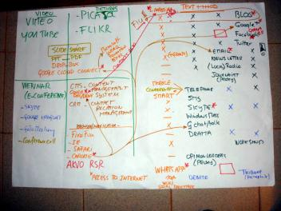

The KM team agreed on the following configuration:
- Skype for office hours using the green / orange / red indicator actively to let other know if they are available for a consult or discussion
- WordPress for blogging on the GLOWS WA-WASH country blogs
- Chrome as browser because of the build in translation possibilities
- Google for:
- Mailing lists / Drive / Documents / Calendar
- Mail client (optional)
- YouTube for archiving video / audio
- Picasa for archiving pictures
For later on the wish list is:
- Google+ as social network
- WhatsApp for communicating at low costs when a WiFi is in reach
- GLOWS portal with AKVO RSR functionality when it becomes available
- Facebook page
- Twitter accounts
Some of the above mentioned applications have been prepared already. For example a Facebook page, Google+ hash-tags (#WA-WASH and #WA-WASHKM) and a number of twitter accounts have been claimed. The KM team is planning weekly / biweekly Skype meetings for sharing and learning as of September 2012.
To complement the KM team works with Google cloud connect to have the Google Drive document synchronized with Microsoft Office word, excel and PPT documents. This add-on to Microsoft will monitor the synchronization whenever the computer is attached to Internet.
Picture 9: The local KM team member environment
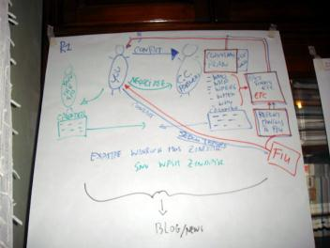
Also agreements were reached on how to work as local KM team member. Picture 9 above sketches the environment they will be operating in. Since all are only for 40% on the WA-WASH project and no earmarked budget is available for travelling the country KM team members will have to merry the WA-WASH and own organization calendars and seek synergies for travelling.
The living documents ‘to-do list’ and a ‘glossary’ of WA-WASH / KM vocabulary can be found publicly at http://goo.gl/8DmMZ. The first document holds a list of activities the KM team will be working on in the first two fiscal years up to September 2013. As mentioned above the focus in FY2 and the rest of FY1 will be on taking stock of who is doing what where and establishing relationship for a network to emerge.

6. Next steps
At the end of the workshop there were three flip over sheets to look at: a parking lot or memo list, the list of things to do in the near future and a reflection on the expectations.

A list of issues to look into now or later
Talk about Power / Access / Language.
Chrome add-ons / zoom pictures.
Mandate + recognition KM team by other WA-WASH partners.
Newspaper / newsletter.
Discuss / Agree on regular KM team conference calls (incl. timing).
KM team needs a basic own communication strategy even if communication overall is not the KM team mandate.
Video / audio storage on the net.
Explain Google account / Google mail / password use.

Picture 10: The workshop brought up other issues unforeseen
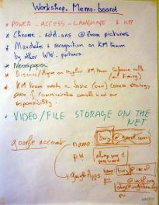

A set of things to do:
Key KM documents in French.
Presentation on WA-WASH.
Create flyer of 1 or 2 pages.
Update glossary.
Peter and Tiney + Koné install Chrome + Google account+ Skype.
Look at instruments Google+ and LinkedIn etc.
Explain relationships with each partner in country.
KM team photo.
Finalise forum documentation timing / planning

Picture 11: The growing “To-do-list” for the KM team
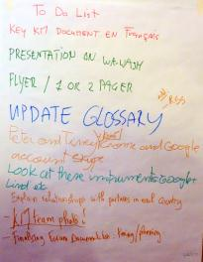

The expectations versus the reflection on them
What participants want to happen?
Clarity about who we work for and within WA-WASH.
KM team to understand schema, tools etc. and test / discuss openly.
Clearly understand what KM is and what is expected of the KM team members in their country.
Bien appréhender le processus de gestion des connaissances et les mécanismes de valorisation.
Partager des experiences des idées entre nous et en I NEED HELP HERE.
Documentation blog (familiarization).

What should NOT happen?
Pas de I NEED HELP HERE
Not asking Qs. Be afraid to ask. Not understand words etc.
Not being (more) confused than I came.
Le survol des aspects techniques (gestion blog, montage video, google doc…).
Atelier “Magistral”
Avoid too long days; allow for informal moments.

Picture 12: Listing of expectations and remarks for revisiting
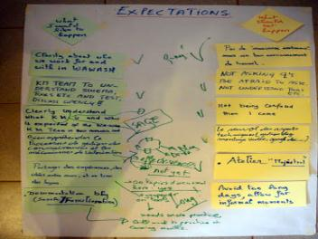

The SaGe group meets the WA-WASH KM team
We had the opportunity to meet the group SaGe (Savoir Gestion): the Burkina Faso chapter of the francophone sister community of the Anglophone KM4Dev (Knowledge Management for Development). This group of practitioners in KM for development aims to establish a network of people in the African Francophone region. WA-WASH – specifically the KM team – will benefit from networking and exchange with SaGe and use the network for tips / ideas.
Picture 13: Meeting the group SaGe (Savoir Gestion)
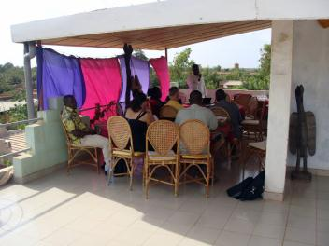
(http://www.km4dev.org/group/km4devfrancophone).
As mentioned before, the skills developed during the KM workshop were put into practice at the Capacity Building Forum the week after (see separate report).

7. References
Bury, P.J. and Ousmane, T., August 2012. WA-WASH Knowledge Management, inception workshop, Ouagadougou, July 2012, a visual story Available at http://goo.gl/I0eSj [Accessed 26 September 2012].
Butterworth, J. ed., McIntyre, P. ed. and Da Silva Wells, C. ed., 2011. SWITCH in the city : putting urban water management to the test. [online] The Hague, The Netherlands: IRC International Water and Sanitation Centre.
Available at: <http://www.irc.nl/redir/content/download/165324/612329/file/SWITCH%20in%20the%20city%20low%20resolution%20web%20version.pdf> [Accessed 6 October 2011].
Available at: <http://www.irc.nl/page/66812> [Accessed 6 October 2011].
Da Silva Wells, C. et al., 2011. Documenting change : an introduction to process documentation. (Occasional paper series / IRC; 47). [online] The Hague, The Netherlands: IRC International Water and Sanitation Centre.
Available at: <http://www.irc.nl/redir/content/download/166216/655538/file/47_OP_Documenting_change_introduction_process_documentation_2011.pdf> [Accessed 13 December 2011].
IRC -The Hague, NL, International Water and Sanitation Centre and USAID -Washington, DC, US, 2010. Conversations with Ghana WAWI partners : key findings of process documentation assessment of WAWI I&II activities : IRC/ WAWI Knowledge Management Research. The Hague, The Netherlands: IRC International Water and Sanitation Centre.
Le Borgne, E., 2011. Vers la gestion des connaissances et l’apprentissage sectoriel au Burkina Faso : comprendre les pratiques actuelles relatives à l’information et aux connaissances dans le secteur de l’eau et l’assainissement. [online] The Hague, The Netherlands: IRC International Water and Sanitation Centre.
Available at: <http://esourcesnouvelles.files.wordpress.com/2011/10/rapport-d-etude_sept11_041.pdf> [Accessed 18 October 2011].
Le Borgne, E., Pels, J., Manning-Thomas, N. and Kerkhoven, R., 2009. Learning for the water sector: quenching the thirst for knowledge and bridging the banks?. In: Knowledge management for development journal, vol. 5, no. 3, p. 197 - 200
Available at: <http://www.informaworld.com/smpp/content~db=all~content=a918917295> [Accessed 21 April 2010].
Odhiambo, F. and Pels, J., 2004. Knowledge management in development organisations : the learn@WELL experience. In: Godfrey, S. ed., 2005. People-centred approaches to water and environmental sanitation : proceedings of the 30th WEDC Conference, Vientiane, Lao PDR, 25-29 October 2004 . [online] Loughborough, UK: Water, Engineering and Development Centre, Loughborough University of Technology, WEDC.
Available at: <http://www.wedc-knowledge.org/wedcopac/opacreq.dll/fullnf?Search_link=AAAA:2424:31239354> [Accessed 19 January 2011].
Pels, J. and Le Borgne, E., 2010. Knowledge management and communication strategy : West Africa Water Initiative Knowledge Management project. [online] The Hague, The Netherlands: IRC International Water and Sanitation Centre.
Available at: <http://www.community-of-knowledge.de/fileadmin/user_upload/attachments/Knowledge_management_and_Communication_strategy_-_WAWI.pdf> [Accessed 30 May 2011].
Pels, J. and Odhiambo, F., 2005. Design of and practical experiences with the Learn@WELL knowledge management module. In: Knowledge management for development journal, vol. 1, no. 2, p. 3-16 : 6 fig.
Available at: <http://journal.km4dev.org/index.php/km4dj/article/viewFile/20/16> [Accessed 2 February 2010].
Pels, J., 2009. Knowledge sharing, information management, communication and IT within WASHCost. In: Knowledge management for development journal, vol. 5, no. 3, p. 215 - 228 : 3 boxes, 1 tab.
Available at: <http://www.informaworld.com/smpp/content~db=all~content=a918918510> [Accessed 21 April 2010].
Pels, J., 2010. Intake report West Africa Water Initiative [WAWI] : knowledge management project : final version, September 2010 . The Hague, The Netherlands: IRC International Water and Sanitation Centre.
Schouten, T., 2007. Process documentation. (Learning Alliance briefing notes; no. 6). [online] Loughborough, UK: SWITCH c/o Loughborough University.
Available at: <http://www.switchurbanwater.eu/outputs/pdfs/WP6-2_BRN_6_Process_documentation.pdf> [Accessed 3 December 2009].
Sow, J.A. and Tiendrebeogo, H., 2010. Programme WAWI KM/ Mali - Niger : rapport de mission, 11 au 19 Mai 2010 [Bamako / Mali]. Ouagadougou, Burkina Faso: Centre Regional pour l'Eau Potable et l'Assainissement a Faible Cout (CREPA).
Sow, J.A. and Tiendrebeogo, H., 2010. Programme WAWI KM/ Mali - Niger : rapport de mission, 11 au 24 Juillet 2010 [Niger (Niamey, Zinder)]. Ouagadougou, Burkina Faso: Centre Regional pour l'Eau Potable et l'Assainissement a Faible Cout (CREPA).
UNDP, Country Sector Assessments UNDP GoAL WaSH Programme Governance, Advocacy and Leadership for Water, Sanitation and Hygiene Volume 1 Mali 2009 ISBN 978-0-615-31175-3
Visscher, J.T., Pels, J., Markowski, V. and Graaf, S. de, 2006. Knowledge and information management in the water and sanitation sector : a hard nut to crack. (Thematic overview paper / IRC; no. 14). [online] Delft, The Netherlands: IRC International Water and Sanitation Centre.
Available at: <http://www.irc.nl/page/29472> [Accessed 23 May 2007].

WASH = Water supply, Sanitation and Hygiene
WA-WASH started with four countries; Burkina Faso, Mali, Niger and Ghana but for the time being (June 2012) activities in Mali has been put on hold until further notice because of the turmoil in Mali.
FY1 = fiscal year 1 = October 1 until September 30
Q1 FY2 = October, November and December 2012 of Fiscal year 2 (2012-2013)

