Poster Presented at
“Sustainable Resources 2003: An International Forum Connecting People with Hands-on Solutions to World Poverty"
University of Colorado, Boulder, Colorado, USA
September 29 to October 4, 2003

GROUNDWATER EXPLOITATION IN THE RIVERBEDS - A VIABLE ALTERNATIVE TO LINKING OF RIVERS IN INDIA

Prof. R. Jagadiswara Rao, Ph.D.
Chairman, Rayalaseema Vikas Parishad (RVP)
Former Professor of Geology, S.V. University
Tirupati, AP 517502 India
Email: jagadishtpt@eth.net, rvp_org80@hotmail.com, rjr@vsnl.com

ABSTRACT

With a land area of around 3.3 million km², India’s population has crossed one billion at the turn of the millennium and is fast racing ahead to become the largest populated country of the world. Over 60% of this population uses around 57% of the land area for agriculture, of which only around 35% gets irrigation water. The objective of the government is to harness the surface runoff of all rivers to provide irrigation water by gravity flow to as much rain-dependent cultivated land as possible. Owing to below the average rainfall during 2001-2003, there was severe shortage of irrigation water in the Cauvery and Krishna River basins. This had led to virtual water wars and political agitations among people of different states and among different regions within the same state. As per a directive of the Supreme Court, the government has created a task force to transfer water from water-surplus to water-deficient rivers. In view of the severe seasonal water shortages felt even in the water-surplus basins, people there are against taking any of their waters.

Exploitation of groundwater has been taken up by millions of individual farmers to meet their dire water needs. Although this has led to local depletion or decline of groundwater levels of serious concern, the quantum of groundwater so far harnessed is hardly one third of the replenishable groundwater of 431 km³ a year. Most of the unutilized groundwater has been joining the shallow sandy alluvium in and adjacent to the multitude of major and minor rivers of effluent nature to ultimately join the sea. The only way this unutilized groundwater could be developed is through large-scale construction of subsurface dams across all the effluent rivers in the country. Such dams provide additional groundwater in arid/semiarid tracts where shallow groundwater in the riverbeds is overexploited. In the absence of such exploitation, they result in substantial base flow in riverbeds that could be diverted into the water-starved canals through gravity flow. The claim that a subsurface dam obstructs groundwater flow on a large scale can be tested upstream of the existing Somasila dam-cum-subsurface dam across the Pennar River through large-scale exploitation of groundwater.

POPULATION OF ANCIENT INDIA

In ancient India, there were highly powerful religious sages who had a profound influence in shaping the modes of living of most of the people. They advocated sustainability of population through a high birth rate matching an equally high death rate. A high birth rate was maintained by making people believe that birth control was not a godly act and procreation of as many children as possible (particularly sons) was essential to avoid going to hell after death. A high death rate was maintained through wars and other man-made disasters, floods and other natural disasters, deaths due to starvation and malnutrition caused by famines, and water-borne and other epidemic diseases. Besides providing solace from the misery caused by the death of kith and kin, they made people to believe that the Goddess Earth cannot bear population beyond a limit and, whenever that happened, God Vishnu would descend on Earth to annihilate the excess population through some way or other.

POPULATION OF MODERN INDIA

The government in the post-independent India took away many of the tasks performed earlier by the sages such as managing lucrative temples and preaching religious values to people. The government took up the tasks of arresting death rate on a massive scale and arresting birth rate on a tardy scale, which has led to a 300% population growth with the population crossing a billion by the turn of the millennium. India, which ranks next to China in population, is fast racing ahead to become the largest populated country of the world. The present trends of population growth indicate that the population of the country might stabilize at around 1.5 billion by the middle of this century.

With the government taking away most of the roles earlier performed by the sages, these sages had to confine to their abodes to preach religious values, encourage construction/renovation of temples and perform religious rituals, while a few sages have been even inciting intolerance against people of other religions and encouraging terrorism at national and global levels. It is necessary for the government to realize that these sages have still profound influence on most people to play a constructive role on subjects such as population control, motivating people to donate for water supply and sanitation works, and keeping the environment clean. These sages have to however realize that, in the changed-context of human values, sustainability of population should be achieved through low birth rate and an equally low death rate, rather than through high birth rate and high death rate.

WATER RESOURCE IN THE PAST

Most land in India till the middle of 19th century was dependent on uncertain rainfall for cultivation, while a small percentage of affluent farmers could have irrigation water through gravity flow through certain community-managed traditional water sources; which include minor irrigation reservoirs across minor streams, weirs across medium-size streams and spring channels near larger streams. Rainwater harvesting was practiced to collect, store and use water in natural or artificial containers, besides direct irrigation of lands through runoff farming and contour catchment farming. In addition, individually owned shallow dug wells with provision to lift irrigation water manually or by animal power were providing considerable water security.

Technology of construction of weirs and reservoirs across major rivers and development of deep groundwater were not known then. As the ancient irrigation structures couldn't cope with the large seasonal differences in rainfall, there used to be periodic recurrence of droughts and famines causing mass deaths due to starvation and malnutrition. The belief that natural waters would remain clean despite any amount of pollution through worship of Goddess Water (Ganga) had led to misuse of water bodies leading to substantial environmental pollution

MEETING GROWING WATER NEEDS

The decision taken under the British rule to take up construction and maintenance of all surface water-based works, whether big or small, to meet the water needs of people, a policy continued even after independence, relieved the people from the maintenance of the traditional community-based works, which were once meeting their water needs. Over 60% of the present population uses around 57% of the land area for agriculture, of which only around 35% gets irrigation water. The objective of the post-independent government has been to harness the surface runoff of all big and small rivers, wherever feasible, to provide irrigation water by gravity flow to as much rain-dependent cultivated land as possible.

Pending government works yielding the requisite water, millions of individual farmers had to take up large-scale exploitation of both shallow and deep groundwater at individual level to meet their water needs. Although this has led to local depletion or decline of groundwater levels of serious concern, the quantum of groundwater so far harnessed is hardly one third of the replenishable groundwater of 431 km³ a year.

Figure 1 shows the year-wise net land irrigated by major and minor works managed by the government and groundwater exploited by people in Andhra Pradesh since its inception in 1956. While the net irrigated land under major and minor works increased for some years and later decreased significantly, the net land irrigated by groundwater has increased steadily from about 0.3 million ha in 1955-56 to 1.9 million ha in 1999-2000.

Figure 1: Year-wise net land irrigated by different water sources in Andhra Pradesh, India

The intensive use of groundwater has led to the local depletion of groundwater or alarming decline of groundwater levels. This has led to the belief that exploitation of deep groundwater is unsustainable and should be banned. The government in turn has been trying through legislation to restrain people from constructing new deep wells in problem areas.

SUCCESS OF TRADITIONAL METHODS

Community managed irrigation works were successful in the pre-independent India because of the ready availability of bonded labourers belonging to certain downtrodden castes to extract any amount of hard work. As this advantage is definitely not there for the farmers now, they naturally prefer to make use of the latest developments in science and technology to adopt laboursaving methods of water development. For example, most of the farmers living in the arid/semiarid hard rock areas were once going in for dug wells necessitating strenuous efforts for several months for construction and subsequent maintenance using the clumsy centrifugal pumpsets. With advances in science and technology, they now prefer to go in for deep wells fitted with deep well pumpsets, which take hardly a couple of days for completion and easy maintenance thereafter.

From the high incidence of deaths in the past due to starvation and malnutrition, a consequence of droughts and famines, the claim that the past community-managed irrigation works provided water security is not correct.

REVIVAL OF TRADITIONAL METHODS

The success stories of some NGOs in providing water security to farmers in some scattered pockets through revival of traditional community-managed irrigation works have led the environmental activists from all over the world including India to campaign for their replication in the rest of the country. To make sure that such works yield enough water on sustainable basis, they advocated ban on major irrigation works and exploitation of deep groundwater, besides economising water use.

The success achieved by these NGOs is more because of the dedicated work of a few individuals who could implement certain stringent rules of water conservation, besides defying certain outdated rules of the Forest, Irrigation and other Government departments coming in the way of effective people's participation in water management. The stringent rules followed in the Alwar district of Rajasthan for example included ban on cutting of green trees, hunting and fishing, mining and industrial activities, grazing by outside cattle, raising of buffaloes, growing water-intensive crops, direct withdrawal of river water and pumping deep ground water. Although this has helped even small farmers to become affluent, enormous harm was done to the non-farm sectors. For example, ban on mining of the world-famous marble deposits of the district has made thousands of people jobless.

Unlike in the past, the population now is so large that mere revival of the traditional methods will not help the country to tide over its water problems. It is essential to take up large-scale exploitation of both surface water and groundwater on a sustainable basis besides bringing radical reforms in the efficient functioning of the concerned government departments.

RIVER BASINS OF INDIA

One way to tackle the water problems is through transfer of surface water from water surplus rivers to water deficient rivers. On the basis of water availability, the principal rivers of India can be broadly classified into the following four categories (Figure 2).

1. Rivers with surplus waters for transfer on a larger scale: Brahmaputra, Mahanadi and the west-flowing rivers in south India

2. Rivers with marginally surplus waters for transfer on a smaller scale: Ganga (Ganges), Brahmani and Godavari Rivers

3. Rivers with marginally deficient waters for import on a smaller scale: Subernarekha, Krishna, Palar and Vagai

4. Rivers with deficient waters for import on a larger scale: Pennar, Cauvery and the rivers between Mahanadi and Godavari and between Krishna and Pennar

The high temporal and spatial variability of runoff in the rivers make even the so called surplus rivers to carry very little water during dry months, which has led to mounting opposition by people from those basins against transfer of any of their waters. The environmental activists are naturally against interlinking of rivers, as it would create several problems including ecological damage and displacement of fauna, flora and native people.

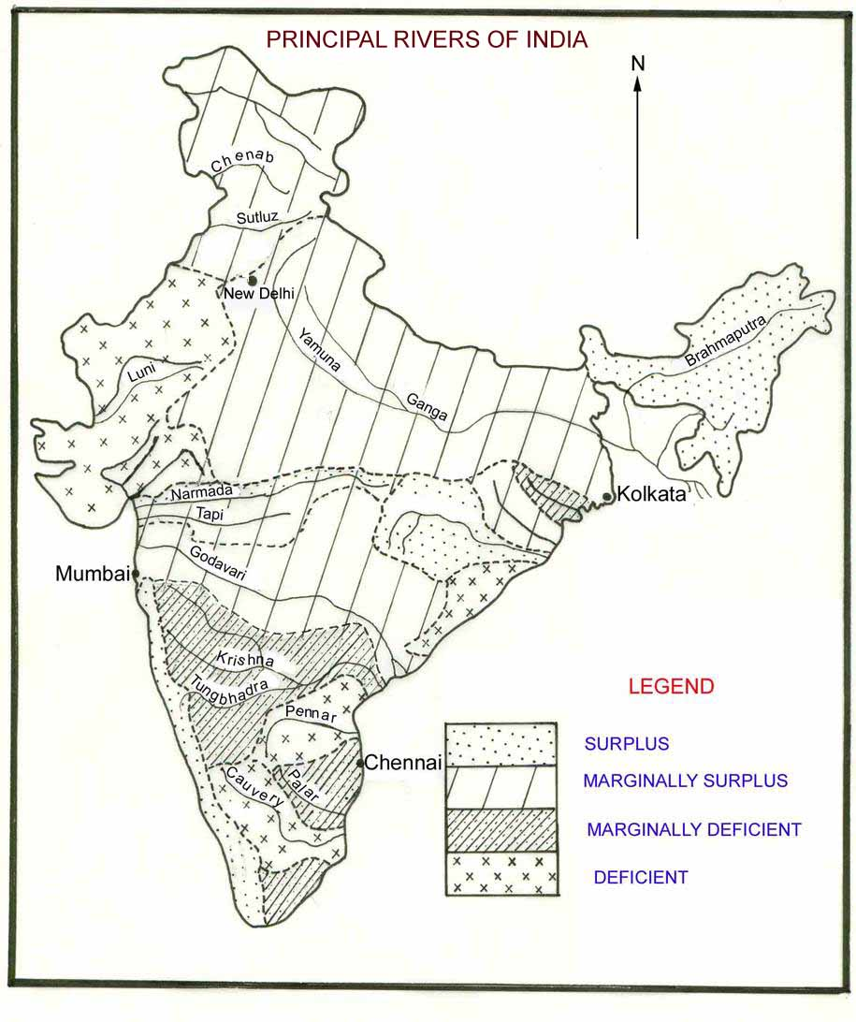
Figure 2: Principal rivers of India

DECISION TO INTERLINK RIVERS

The magnitude of the 2002-drought in south India was so severe that there were severe shortages of surface flows in the Cauvery River basin in the states of Karnataka and Tamil Nadu. The flows in the Cauvery River were so meagre that even upstream reservoirs in Karnataka couldn't be filled up completely and Tamil Nadu couldn't get any water for irrigation. Despite repeated demands and requests by Tamil Nadu, Karnataka declined to release any water. The Supreme Court had to then intervene for release of some water to Tamil Nadu. The Karnataka people paralysed life forcing the state government to face even contempt of court rather than part with the Cauvery waters. There was a virtual water war among people with even intellectuals dividing themselves on regional lines.

The Supreme Court in a bid to stop recurrence of such events in future directed the government to go ahead with the interlinking of rivers to transfer waters from the water-surplus river basins to the water-deficient basins. This has led to the creation of a Task Force to work out the modalities for the implementation of the project.

SURFACE WATER AND GROUNDWATER AVAILABILITY

The mean actual surface runoff, mean utilisable surface runoff, live surface storage created so far and replenishable groundwater in the principal river basins of India are given in Figures 3 to 6. Although the average actual surface runoff is 1922 km³, the utilisable surface runoff is 690 km³ and the live storage created is 176 km³. Except when river waters are diverted by weirs and barrages, the quantum of surface water that could be utilised in a river basin is only around twice the live storage created. The percent live storage so far created to actual surface runoff ranges from 0.2% in the Brahmaputra basin to 100% in the Sabarmati basin. There is gross underutilisation of surface runoff in rivers such as the Brahmaputra, Ganga, Mahanadi and Godavari where there is little feasibility to create live storage, while there is over-exploitation of surface runoff in rivers such as the Krishna and Cauvery where there large live storage could be created.

The natural storage space for groundwater, on the other hand, is around 12.5 thousand km³, while the quantum of replenishable groundwater, which coincides with the utilisable groundwater for use by irrigation and non-irrigation uses, is 451 km³. As the present level of utilisation of the replenishable groundwater is hardly around one-third of that, the balance groundwater has been mostly joining the shallow sandy alluvium in and adjacent to the multitude of major and minor rivers of effluent nature to finally join the sea as base flow or underground runoff. Unlike problems of depletion and alarming decline of groundwater levels encountered in the exploitation of groundwater in the upland areas, no such problem is encountered while exploiting groundwater underlying the riverbeds.
Figure 3: Mean actual surface runoff of the principal rivers of India

Figure 4: Mean utilisable surface runoff of the principal rivers of India

MYTH OF SURPLUS RUNOFF IN BRAHMAPUTRA RIVER

The oft-repeated statement by the proponents of river linking that there is surplus water in the Brahmaputra River is only a myth. It is no doubt correct that the Brahmaputra River discharges 629 km³ of water a year on the average into the sea every year. The high temporal variability of rainfall and surface runoff in the river and the steep slope of land allow for utilising only around 24 km³ a year. Owing to non-availability of suitable sites for reservoir construction, the live storage so far created is just 1.1 km³. On the other hand, the replenishable groundwater in the basin is 27 km³.

More than that, Brahmaputra River being a transnational river, no transfer of the Brahmaputra waters can be taken up without the consent of Bangladesh. Before contemplating to transfer any Brahmaputra waters outside the basin, it is first necessary to solve the water shortages faced within the basin in the dry months. This could be best done by harnessing groundwater beneath its riverbed.

MYTH OF SURPLUS RUNOFF IN GANGA RIVER

India built Farakka barrage across the Ganga River close to the Bangladesh border in 1974 to make Kolkata an all-season port. This barrage made people living on subsistence agriculture and fishing in Bangladesh to have no water in summer. The two countries entered into a new treaty in 1996, as per that, India gets 40,000 cusecs when the flow is more than 75,000 cusecs, Bangaladesh gets 35,000 cusecs when the flow is between 75,000 and 70,000 cusecs and the two countries share equally when the flow is less than that.

Although the new accord helped Bangladesh to get more Ganga water than what it was getting before the construction of the barrage, Kolkata to have an all-season port was defeated. The proposal of India to solve the problem through the Brahmaputra-Farakka link was opposed by Bangladesh, while the proposal of Bangladesh to construct upstream reservoirs was opposed by India, Nepal and Bhutan.

When a relatively small issue of maintaining enough river flow to keep Kolkata an all-weather port could not be so far achieved, how can anybody believe that the Ganga waters could be imported to other basins?
Figure 5: Live storage so far created in the principal river basins of India

Figure 6: Replenishable groundwater runoff in the principal river basins of India

MYTH OF SURPLUS RUNOFF IN GODAVARI RIVER

There is good scope to harness surface water in the Godavari River. Its non-utilisation gave an impression that it could be transferred to the water-deficient basins in the south. This river flows north of the Telangana region comprising of over 400 thousand ha of rain-dependent land craving for irrigation water. Apart from financial crunch, a number of other problems such as location of the river at a lower elevation, submergence of valuable land and short life of any reservoir constructed owing to high sediment load have been coming in the way to make use of these waters.

The government has proposed to construct a large number of small reservoirs across the river, pump surface water into reservoirs constructed in upland areas and supply irrigation water to lands through gravity flow. Even this approach has its problems such as submergence of some valuable lands adjoining the river and difficulty of acquiring private lands for reservoir construction in the upland areas. The problems coming in the way of harnessing Godavari waters for use within the state are equally valid for the inter-basin transfer of those waters to other basins.

SHARING OF KRISHNA WATERS

With an annual gross 75% dependable yield of 59 km³, the Krishna River has an annual gross yield ranging from 118 to 31 km³/year. The Krishna Water Disputes Tribunal has allocated 16 km³/year to Maharashtra, 20 km³/year to Karnataka, and 23 km³/year to Andhra Pradesh. In addition to sharing the dependable yield, all these states managed to get additional allocations on the plea that the basin gets additional water through regeneration of water through irrigation and through import of the Godavari waters at a future date.

When surface runoff is less, Andhra Pradesh alone will be experiencing delays and/or scanty supplies. Despite that, Andhra Pradesh has been going ahead with the construction of many new irrigation projects utilising the flood flows available in less than 75% of years. The right course of action for Andhra Pradesh would be to agree for sharing the extra water generated in years of excess rainfall and to demand for a regulatory mechanism to ensure that the other two states do not utilise more than their allocated shares in years of normal rainfall. The most important thing is to evolve a mechanism for each of the states to forego their allocated share, including production of hydroelectric power by Maharashtra involving diversion of 3 km³/year of Krishna water to the Arabian Sea during years of low rainfall.

HARNESSING GROUNDWATER UNDER RIVERBEDS

Unlike surface runoff of rivers, showing high seasonal variation, the underground runoff is remarkably constant. Although flood flows of rivers cannot be harnessed without creating adequate live storage, the large static ground storage space available beneath the riverbeds allows for large-scale usage of groundwater. This storage space acts as a buffer to take care of the vagaries of monsoon and river flows with more groundwater pumped under drought conditions and more recharge of groundwater under flood conditions. Although the life of man-made reservoirs is quite low owing to high sediment load in river waters, there is no such problem for underground reservoirs. The question of groundwater depletion doesn't arise owing to recharging of groundwater by surface water available at all times. Excessive groundwater exploitation in the riverbeds doesn't cause any decline of groundwater levels in wells functioning in the upland areas. As groundwater is free of suspended solids and bacteria, it could be used without any treatment and there will be no clogging of pumping installations. One way to utilise this groundwater consists in the large-scale pumping of that water through a large-number of high-yielding wells of proper design at properly selected sites on a foolproof basis.

When a river is located at a lower elevation than the surrounding land, it is a standard engineering practice to pump surface water in the river through jack wells. To obtain adequate water when the surface runoff is less, it is necessary to either construct a dam across the river or divert river flows periodically into the jack wells through channels during summer. Besides need for treatment, the high concentration of suspended solids in the river may clog the pumping installations. All these problems could be overcome by resorting to pumping of groundwater rather than surface water in the river beds.

USE OF SUBSURFACE DAMS TO CONSERVE GROUNDWATER

Groundwater flow in an alluvial formation consisting of well-sorted coarse sand beneath a riverbed can be around 100 m/day, while it is only a tiny fraction of one m/day in the rock surrounding it. If a subsurface dam of proper design could be constructed to prevent the entire flow of groundwater through or around such an alluvial aquifer having a width of a km and a depth of 30 m, the quantum of groundwater prevented from flowing would be more than a km³/year.

Such a subsurface dam could be constructed at a site across the river where good quality sand occurs and hard rock is met at shallow depth both at the bottom and flanks by driving two closely spaced diaphragm walls keyed into the bedrock for some depth, and then making the intervening alluvium impervious through grouting. Such a construction doesn't involve submergence of any additional land and doesn't pose any seawater intrusion. No recurring expenditure is involved in its maintenance. It is however necessary to ensure that the yields of wells if any in the downstream are not unduly affected.

SUBSURFACE DAMS ACROSS MAJOR RIVERS

In riverbeds where there is no exploitation of groundwater in the upstream, the groundwater blocked by a subsurface dam enhances either the storage of water in the reservoir created above it or substantial base flow in the downstream. In the latter case, the additional flows will be a boon for water-starving canals particularly located in the coastal tracts.

A subsurface dam across the Ganga River upstream of the Farakka barrage helps Kolkata to become an all-weather port, while people in parts of Bangladesh could have subsistence agriculture and fishing even during summer.

A subsurface dam across the Godavari River upstream of the Dowleswaram barrage ensures no shortages of water for the Rabi crop in the Godavari delta.

A subsurface dam across the Krishna River upstream at the Krishna barrage at Vijayawada or across the Cauvery ensures adequate water for two crops in the delta irrespective of the vagaries of surface runoff.

Such subsurface dams could be constructed across every small river joining the sea to put the associated groundwater presently joining the sea into use without the danger of any saltwater intrusion.

SOMASILA DAM – A TEST CASE FOR SUCCESS OF SUBSURFACE DAMS

As the entire Pennar River basin is bordered in the east by the impervious Velikonda hill ranges, the entire unutilised surface water and groundwater of the basin had to pass through the narrow Somasila gorge to flow in the plains for a distance of around 100 km to join the sea. With the construction of a dam-cum-subsurface dam, a good portion of this water now remains upstream of the Somasila reservoir in Kadapa district (Figures 7 and 8).

Although the riparian rights over the utilisation of surface water within the reservoir rest with the lands downstream of the reservoir, at least one half of the unutilised groundwater of over 2 km³/year held by the dam could be utilised in the upstream. The claim that a subsurface dam obstructs groundwater flow on a large scale can be tested through large-scale exploitation of groundwater upstream of this reservoir on a sustainable basis.

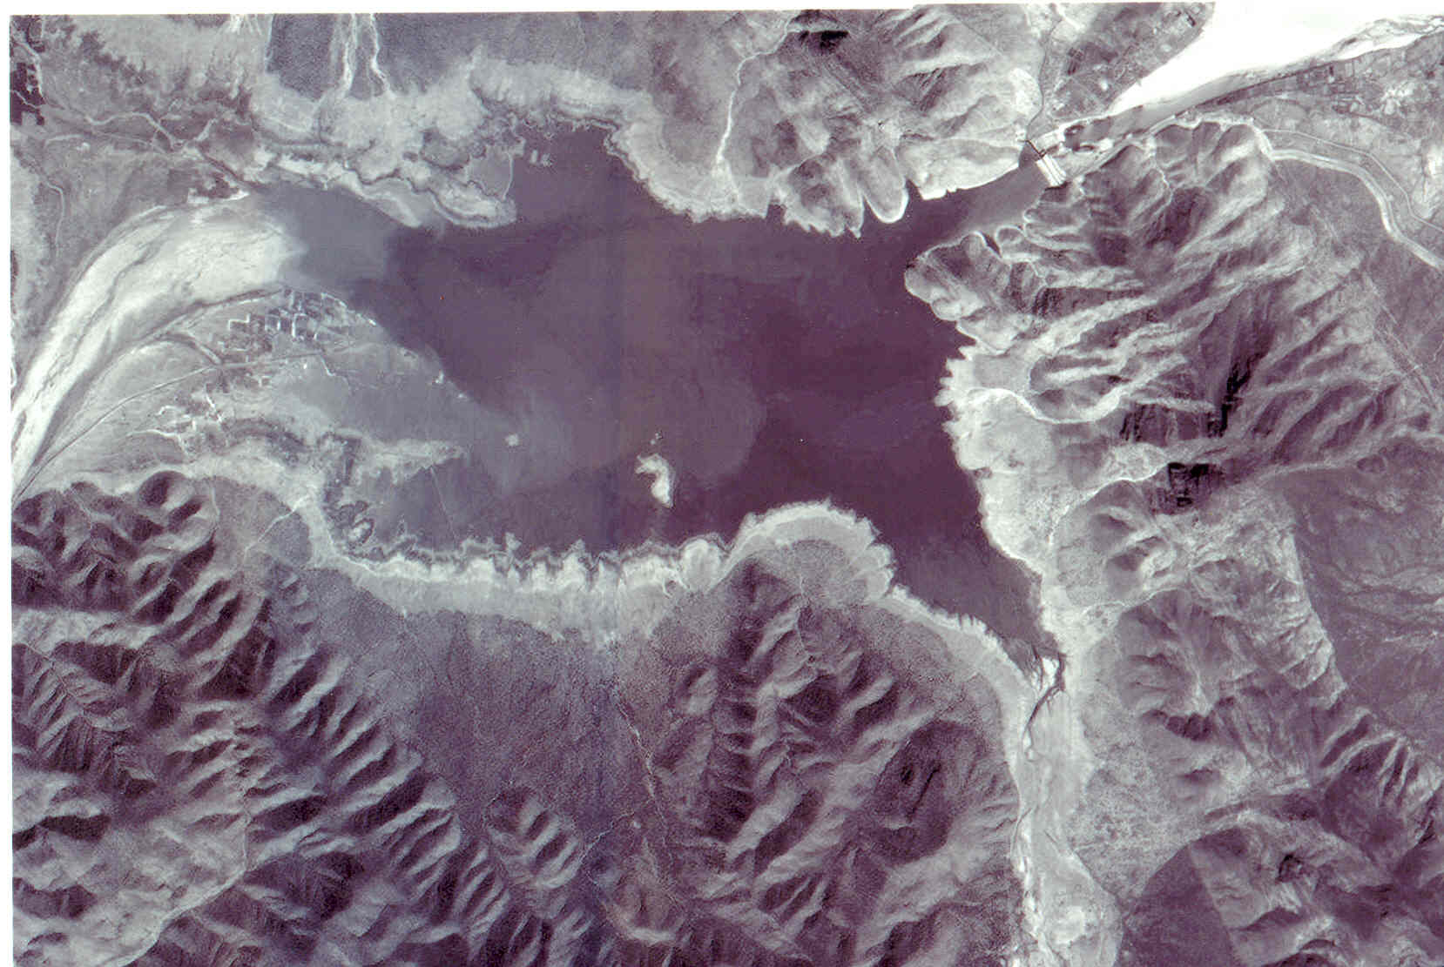
Figure 7: Satellite picture of the dam-cum-subsurface dam constructed across
the Pennar River at the Somasila gorge in the Velikonda hill ranges
receiving substantial base flow

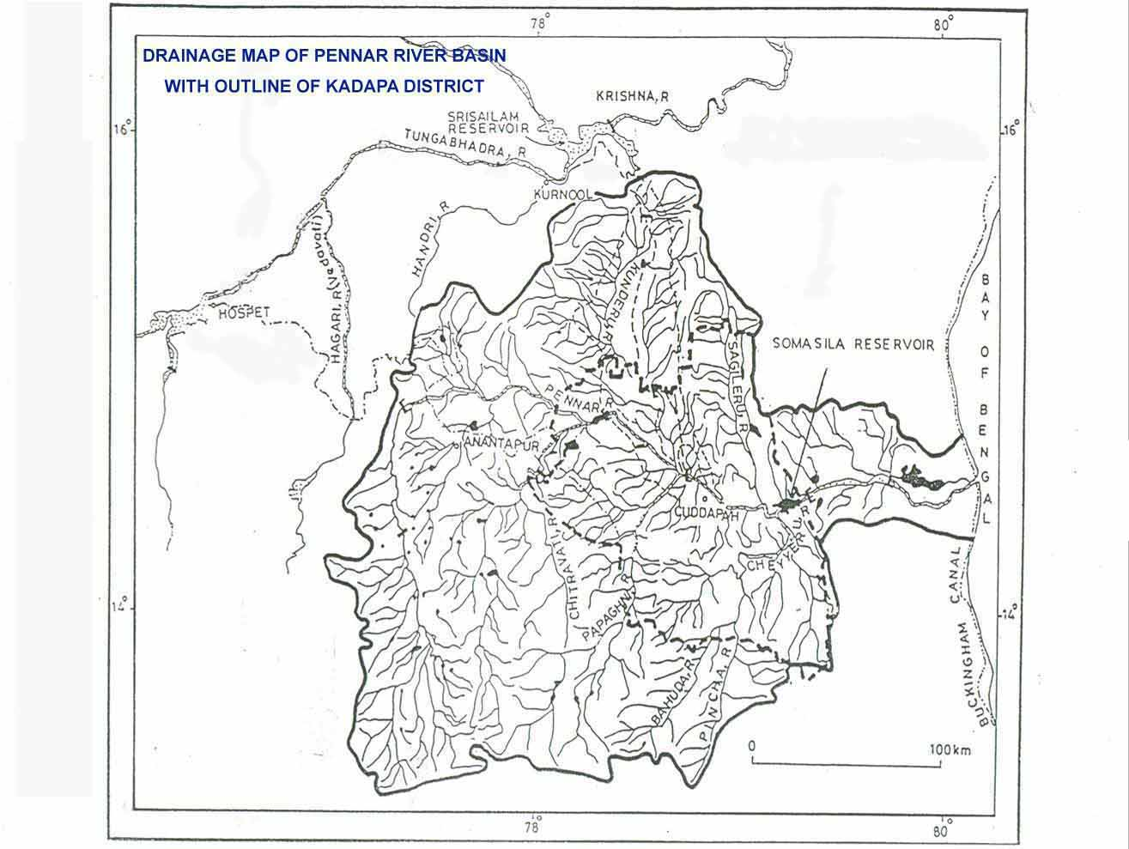
Figure 8: Pennar River basin

CONCLUSIONS

Construction of subsurface dams is a cost-effective way of conserving groundwater in the effluent rivers without incurring any recurring expenditure. Although a cascade of tanks is required to store flood runoff in a river, groundwater flow is so slow and uniform that a few subsurface dams would be able to conserve that water. If a subsurface dam is constructed across any effluent river of any size located in any climatic zone to prevent the entire flow of groundwater flowing through or around the permeable alluvium, the following purposes are served.

- When constructed across a minor effluent stream in an arid/semiarid tract, it provides much-needed water through shallow wells constructed in sandy alluvium in the upstream.

- When constructed across a large river, which is unable to provide adequate water to the existing canal network during lean season, it substantially increases the base flow of the river for diversion into the main canals by gravity flow.

