Dhaka, Bangladesh, 31 January -2 February 2012

Asia Regional Sanitation and Hygiene

Practitioners Workshop

The business of the Honey-Suckers in Bengaluru (India):

The Potentials and Limitations of Commercial Faecal Sludge Recycling – an explorative case study

Joep Verhagen (IRC International Water and Sanitation Centre), Elisabeth Kvarnström (Vectura), Mats Nilsson (consultant), Vishwanath Sankrathai, Shubha Ramachandran Karan Singh

On-site sanitation and the sanitation challenges ahead
The global urban population is increasing rapidly; the number of urban dwellers is set to increase to 4.2 billion in 2020 out of a projected global population of 7.7 billion, an increase that is to a large extent taking place in rapidly growing small and medium-sized towns (UN-Habitat, 2009). Typically less than 15% of urban dwellers in African cities rely on centralized collection of wastewater (Schaub-Jones, 2005).

In Asia the percentages of un-served population are equally high. In India, 40% of the 350 million dwellers are connect to a sewerage, however only 9% of the sewage is treated, 29% of the urban population is using a septic tank, and 17% is using a pit or vault latrine (AECOM and SANDEC, 2010). The part of the urban population that is not served by sewerage networks will have to rely on different forms of self-services to cover their basic needs. Most of these self-services are some kind of combination of on-site containment such as latrines of different kinds, or septic tanks, with off-site disposal. In the best of cases, the faecal sludge gets collected and then emptied at a designated site where sludge dewatering takes place. However, more often the collected faecal sludge gets disposed of haphazardly and illegally. (Koné et al, 2010).

Valfrey-Visser and Schaub-Jones (2008) discuss new options for this waste as a resource as one important topic to develop the treatment segment of the on-site market. The fact is that faecal sludge is used at a large-scale as nutrient input into agriculture in different settings around the world. It has been estimated by Scott et al (2004) that approximately 700 million people in 50 countries eat food from crops irrigated with untreated or inadequately treated wastewater from sewage systems on a total areal surface of at least 20 million hectares. Partly, the nutrient recycling is done by on-site sanitation entrepreneurs who empty the faecal sludge on agricultural fields instead of in water courses, open drains and vacant plots. These practices, albeit unsafe from a health perspective, have emerged without external support. The faecal sludge thus presents a value to farmers in the sanitation chain, which is explored by on-site sanitation entrepreneurs. (Seidu, 2010 and Bo et al. 1993).

Objective and Research Questions and Methodology

The main objective of this explorative case study is to come to a better understanding of the potential of re-use of human waste on a commercial basis as a driver for improved urban sanitation services. To analyse the business of on-site sanitation entrepreneurs, we have used a business model that is presented in Error: Reference source not found. Such a business model concept is really just a structured way of looking at a business, mapping the activities of entrepreneurs and entrepreneurial entities. In this context, the entrepreneurs are almost by definition profitable since they would not exist otherwise (compare for example with municipal services that could provide the ‘same’ services but where the decision to provide services is not based on a possible profit). So in our mapping we investigate how profits are made, and secondly the inter-linkages between the agricultural customers of nutrients in faecal sludge, i.e. the farmers, and the households that use the latrine emptying services.

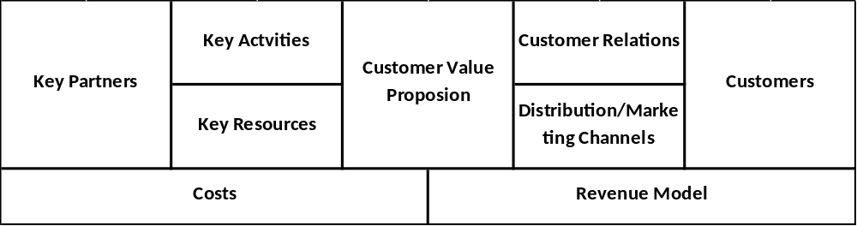
Figure 1 Business model building blocks (Osterwalder, A. and Pigneur, Y. (2010)
As mentioned, there is limited knowledge of the roles of small-scale service providers in the urban sanitation sector (Valfrey-Visser and Schaub-Jones, 2008). For that reason we chose to use an explorative case study approach to tackle the objective of the study. Case studies are commonly used in social science and they give a possibility to generalize results as long as it is understood that the generalizations are of an analytical character and not statistically proven (Yin, 2003).

Current Sanitation Services in Bengaluru

Bengaluru, according to the recently conducted and published census of 2011, reports a population of nearly 8.5 million. With an average household size of around 4.5 (from the Comprehensive Development Plan of 2011) there are approximately 1.9 million households in the city. The sole authority responsible for the management of sewage and sullage in the city is the Bengaluru Water Supply and Sewerage Board (BWSSB).

The Ministry of Urban Development of India indicates that 37.6% of the properties are connected to the sewage network (GoI 2009). In February 2011, the Comptroller and Auditor-General (CAG) of India reported that the sewage network only covered 317 out of 800 sq. km of the city. The Karnataka State Pollution Control Board (KSPCB) admitted in its reply to the CAG that 53% of the sewage generated is directly discharged in the environment without any form of treatment. Moreover, the CAG reported that the 17 sewage treatment plants (STPs) are functioning well below their capacity: in the period 2005 – 2009 the 17 STPs treated 251 MLD against an installed capacity of 781 MLD (Hindu, 2011).

The remaining 63.3% of the population needs to rely on different form of self-service mostly a combination of on-site containment and off-site disposal. This study focuses on a combination of holding tanks or soak pits that are constructed by individual households – in many cases on the public road – and that are emptied by the so-called honey-suckers. These honey-suckers dump their waste illegally on vacant plots and with farmers.

There are a number of policies and by-laws regulating household sanitation and the treatment and disposal of faecal. However, it needs to be noted that the enforcement of policies and regulations is often weak or absent altogether (CSE 2011, Citizens Matter 2011, and Baken 2008). The Bruhat Bengaluru Mahanagara Palike (BBMP Greater Bangalore Municipal Body approved building construction plans. They insist on a toilet of a minimum dimension being shown on the plan but does not insist on any form of disposal to be indicated on the approved plan or on the completion certificate.

A number of years ago, the Karnataka State Pollution Control Board (KSPCB) has mandated that ‘Sewage Treatment Plants be built and operated in individual residential complexes having fifty or more dwellings, or generating 50 m3/day or more of sewage (Ananth S. Kodavasal 2011). The KSPCB is responsible for defining standards of release of wastewater however it hardly monitors domestic waste coming from households nor does it insist on any specific form of sewage disposal for individual households (CSE 2011).

The Bengaluru Water Supply and Sewerage Board (BWSSB) does not monitor or insist on any form of sewage disposal or treatment in areas that are not being served by sewerage. Neither does the BBMP register or monitor the activities of the honey suckers nor do they monitor or insist upon particular forms and places of disposal such as private agricultural land or sewage treatment plants or even landfills.

The Environmental Protection Act (EPA) explicitly prohibits discharge of pollutants in excess of prescribed standards. However, the Centre of Science and Environment states that nearly 80% of the water pollution is caused by discharge of untreated domestic wastewater from urban centres, responsibility of which lies often with the government supported PHEDs and ULBs. Due to lack of technical, managerial and financial capacities these agencies are not able to carry out their duties … (CSE 2011, 35).

Results

A business model for tanker operators in Bengaluru

The Customers of emptying services
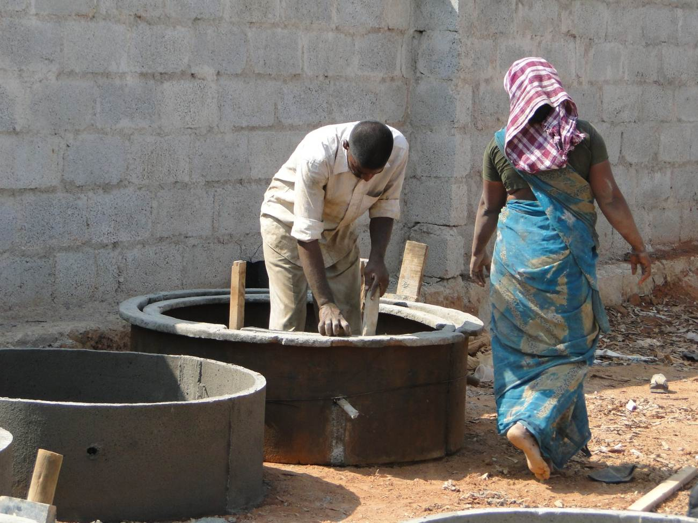
Domestic and institutional properties that are not connected to the sewerage network need to rely on some form of self-service. The clients of the honey-suckers either have constructed a large holding tank, a septic tank or and large complexes have a small Sewerage Treatment Plant (STP). The construction of the holding tanks has developed into a separate industry with small-scale contractors that have specialized in the construction of circular holding tanks with a depth of 20 feet and a diameter of 6 feet. In their turn they are serviced by small-scale companies that produce the concrete rings.
Figure 1 : production of rings of holding tank (source : Vishwanath S.
The price paid for services varied between less than INR 500 and INR 1,400 for the emptying of a holding tank or septic tank. Though we did not investigate the income of the customers, the infrastructure that is needed within the property clearly puts them in the middle and higher income groups.

The lowest price was paid for an apartment block emptying away treated wastewater and ordering 6-9 tanker trucks per day for that service and the highest price is paid by an individual home owner who empties their soak pit yearly. All interviewees mentioned to be satisfied with the service provided by the honey-suckers.

Interview with tanker operators
Four owners of the emptying businesses and one driver working for a fifth tanker operator were interviewed. Four of five (all tanker owners) mention good money in the business as reason why entering the market. The businesses seem small, 3 of the interviewees are working with one truck only and the largest player had eight trucks. Only two of the interviewees reported paying tax, indicating that the operators are working in an extra-legal environment. We have chosen the term extra-legal and not ‘informal sector’ to emphasize that there are costs not only of being in the informal sector but also that a set of laws accommodating long run sustainable businesses may be missing.

Customer Value Proposition (CVP)
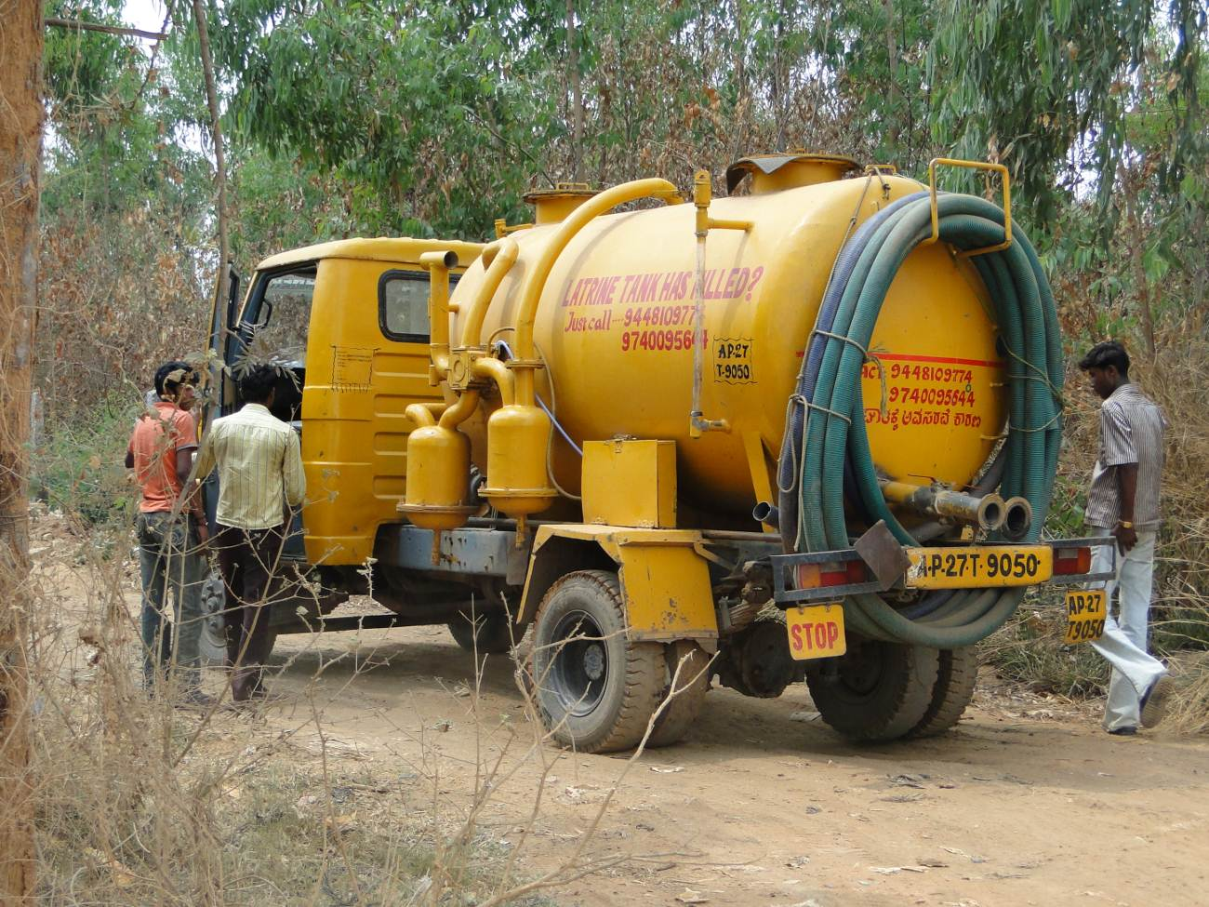
The CVP in the primary market (removal of faecal sludge) is that the customers want cleanliness and working latrines. In the secondary market (dumping of faecal sludge), the farmers want nutrients (and water) to their fields and crops. The operator charging the highest price for emptying was also the only interviewee that pronounced having a quality offer (upon a phone call, the truck will be on spot within an hour and the job is done in 15 minutes), which can indicate that there are possibilities for development of qualitative offers.

Customer
In a sense the tanker operators have a mass market service but with a somewhat restricted geographical reach. The customers who want their latrines emptied broadly face the same needs and problems. However, this business also could, and in some instances do, face a second set of customers, the farmers. Thus market for emptying latrines actually creates a potential market for returning nutrients to agriculture. In a sense the tanker operators are facilitating the ‘interaction’ between households and farmers, acting as the link between the households and farmers. For our purposes we can talk about the emptying of latrines as the primary market and the farmers as the secondary market, where the secondary market is dependent on the primary market being in place.
Figure 2 : Honey Sucker (picture : Vishwanath S.)

Key activities
The key activity in the first market is emptying of latrines, and for the second market it is emptying of faecal sludge on farms. One key activity is/could be the relationship-building with farmers (refer next section).

Key resources
There is no doubt that the fleet of tankers is crucial and in addition, the drivers to operate these. Especially for the secondary market, the network of these drivers with individual farmers that allow reuse of the sludge should be considered an asset. Our study gives some evidence that the relations are currently being built between the drivers and the farmers, rather than the tanker operating business proper and the farmer.

Key partnerships
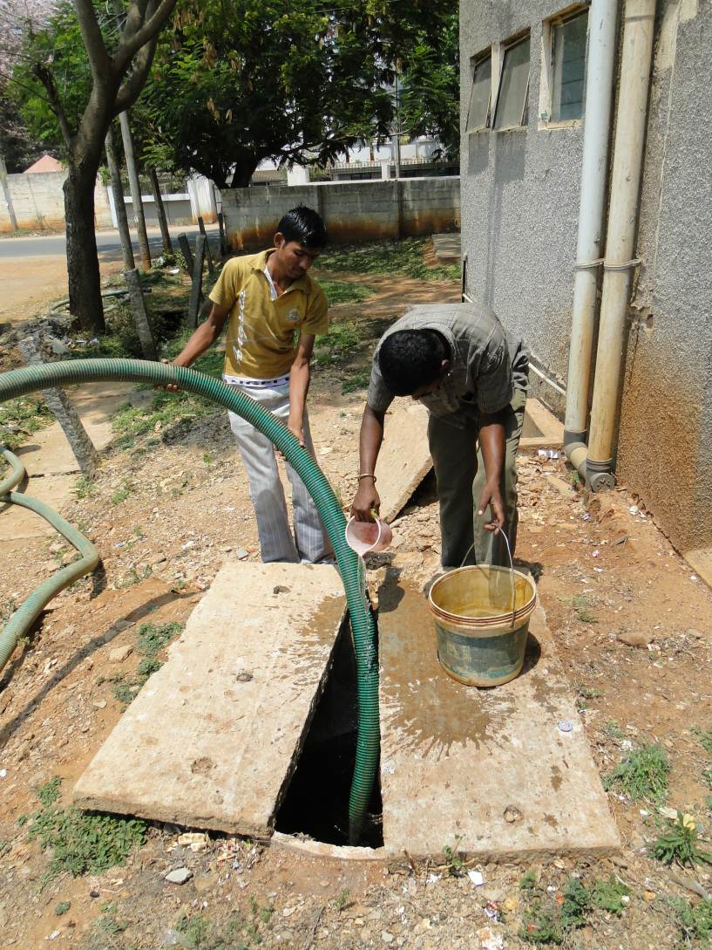
No key partners were identified in the interviews with the tanker operators. This is likely due to the current extra-legal character of the honey-sucking business as building partnerships requires higher transaction costs in such an environment. However, we think that the current institutional setting with operators having to consider short run profitability rather than long run possibilities does not encourage such business innovation.
Figure 3 : Emptying of holding tank (source : Vishwanath)

Channels
It looks as if the main current marketing channel towards the primary market is through word of mouth. Only two honey suckers were mentioned in the yellow pages. The channel towards the secondary market seems to go through the drivers. In their strife to find somewhere to empty the lorries the farmers may be targeted. We have some evidence of farmers paying for the load but it seems to go into the drivers – additional – earnings and is unlikely to be reported to the tanker owners.

Customer relations
We found no evidence of long-lasting or special relationships between customers and tanker operators in the primary market: at the moment, the households only expect to get their latrines emptied on a need basis against a ‘reasonable’ price and with good speed of delivery of the service. Nevertheless, with the farming community, we expect more relationship marketing to emerge with at least implicit contracts for sludge delivery.

The revenue stream
Clearly, the tanker operators are making profit; otherwise they would not be in business. The good money in the business was also confirmed during the interviews by all owners of businesses. In some cases, the farmers do pay the drivers to access the faecal sludge. Table 1 provides an overview of the range of costs and revenues. However, the data provided in the table should be considered as an indication and are insufficient to calculate an annual profit.

Table 1 : Estimated revenues and costs for tanker operators (N = 5)
Revenues | Charge at emptying | The charge varies between INR 800-3,000 per emptying.
Revenues | # of customers per day | 3-4 customers per day, up to 6-8 customers per day in monsoon (one operator)
Costs | Capital costs, office space, equipment | None of the interviewees has offices. The costs of trucks vary between INR 400,000 (used) to INR 1,700,000 (new).
Costs | Fuel costs per month per vehicle | INR 12,000-30,000
Costs | Yearly maintenance costs | INR 10,000-75,000
Costs | Salary costs | Varying between INR 3,000 – INR 15,000
Costs | Overhead costs | One mentioned interest rate on a loan on the tanker truck and another the monthly costs for the second-hand permit
Costs | Costs of legal disposal of sludge | INR 8 – 12/1000 L. Only two operators mentioned legal disposal costs.

Cost structure
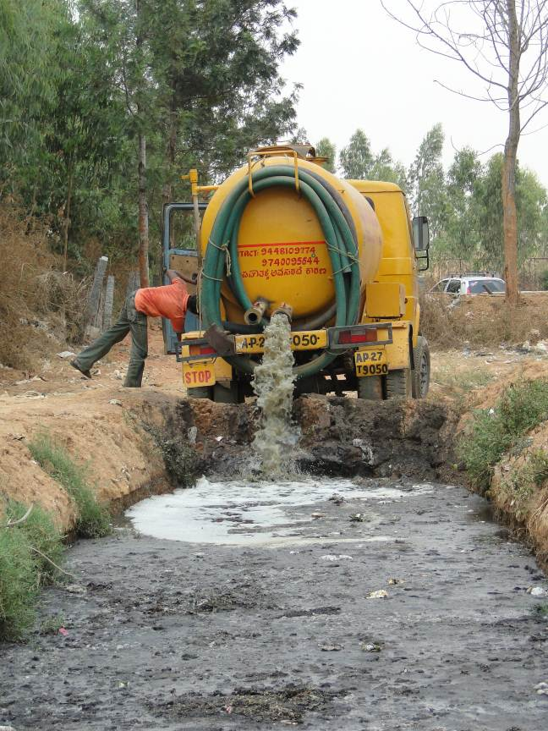
The fixed and variable costs for the tankers as well as the salaries to the drivers are the main costs for the tanker operators. However the cost for being extra-legal is hard to determine: some of the respondents mentioned that had to pay bribes. However, the extra-legal character of the tanker-operating business is likely to have significant costs:
Figure 4 : Tanker dumping sludge in drying pit (picture : Vishwanath S.)

An infrastructure services are is likely to benefit from scale economies. However, none of the operators interviewed was running a large-scale business. This is likely to be linked to the non-legal status of their operations.

Costs of financing as well as the costs of building partnerships which can be relied upon to be enforced by legal institutions should be lower for entities acting in an accommodating institutional setting.

The business of re-using human waste
This section summarizes the findings of the semi-structured interviews with the farmers. This section mainly focuses on the advantages and disadvantages of the re-use of faecal sludge by the farmers and their relationships with the tanker operators.

Results from interviews with farmers
Most of the farmers that were selected for the interview were growing different crops for the markets and were employing a number of labourers on their farm. The size of their lands varied between 1 and 5 acres and they grow crops such a coconut, Sapota (Chickoo), Arecanut, bananas, paddy, tomatoes, beans, flowers, vegetables, etc. Four out of 5 farmers sell their produce to wholesalers.

Basically farmers use two methods to apply faecal sludge to their crops:
- Faecal sludge from the honey suckers is emptied in a large pit. After the sludge is dried (mostly after three months) it is applied to the crops for instance coconut trees. The water from the sludge either seeps away or evaporates.
- Wet faecal sludge is directly applied to the farm land. This is done either through trenches (for instance in between banana trees) or on vacant farmland that will be farmed later in the season.
One of the interviewed farmers was selling dried faecal sludge to other farmers. For this purpose, he had dug one large additional pit on his land to dry the sludge.
Start of re-use of FS and relationship with tanker operators
Three out of 5 farmers mention that the use of faecal sludge for farming is an old existing practice that was passed on by their parents. From their perspective there was no barrier to re-use human waste.. In most cases, tanker operators did not use any formal marketing channels to identify farmers for the dumping of the faecal sludge. In two cases farmers were approached by tanker operators and in two other cases farmers seem to have invited, whilst the fifth farmer is mainly re-using the faecal sludge from his large extended family.

Advantages and disadvantages of the use of faecal sludge
Faecal sludge contains macro plant nutrients, such as nitrogen (N), phosphorus, (P) and potassium (K). It also contains so called micro nutrients. These micro-nutrients are as essential to the plant as the macro nutrients but which are needed in less quantity for a healthy growth of plants. All farmers interviewed in this study are content with the fertilizing value of the faecal sludge. Four farmers mentioned that there yield has gone up with the use of faecal sludge. One farmer said that the faecal sludge is more efficient than using Farm Yard Manure (FYM), and that he needed only half as much dewatered faecal sludge compared to FYM for the same yield.

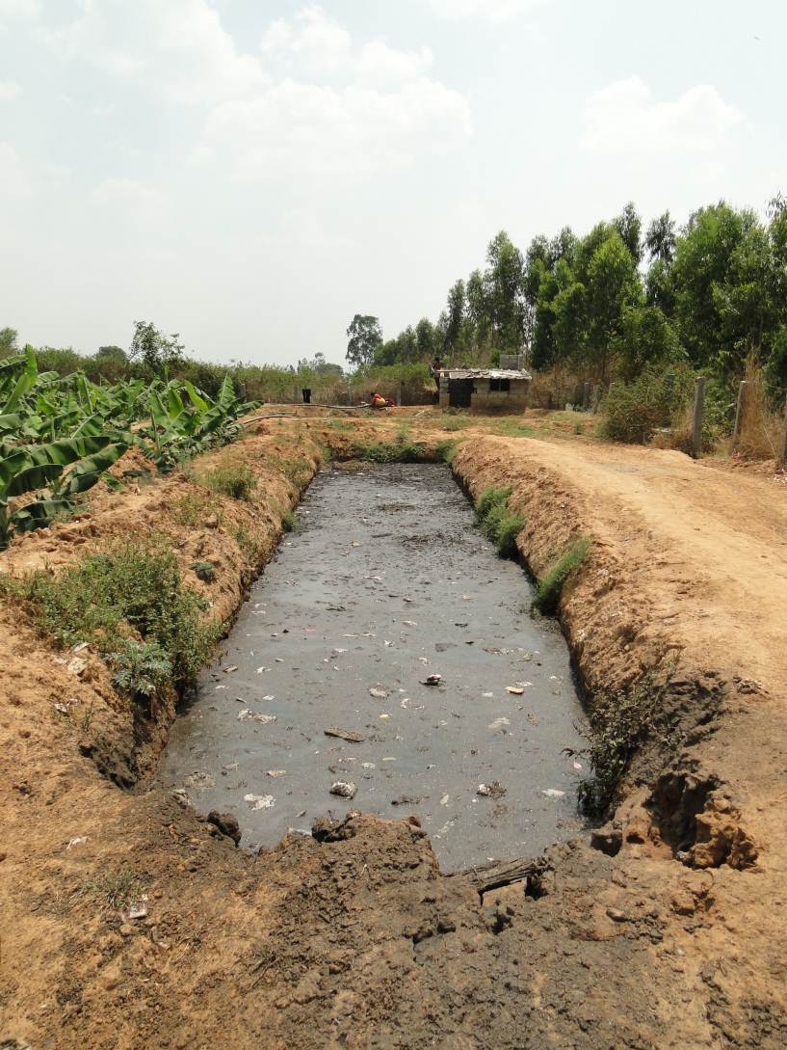
Farmers mentioned that the use of faecal sludge instead of farmland manure had financial advantages. Moreover, the stated that the revenues of the crops grown with faecal sludge were at least equal to those grown with regular manure as yields and price of the crop were not affected by the type of manure that was being used. An estimate of the financial gains of the use of faecal sludge shows that farmers save between INR 8,000 and INR 170,000 annually. One of the farmers was selling faecal sludge to other farmers. He estimated that he was earning around INR 1,500 tractor load of dried faecal sludge. As the farmer mentioned that he received approximately 800 tanker loads of 4,000 litres each annually, this would mean an additional income of approximately INR 1.2 million.

Health impacts of the use of faecal sludge
Use of non-treated faecal sludge can pose health risks to both those working in the fields and to consumers of the agricultural produce, in terms of diarrheal disease transmission. Two out of five interviewees acknowledged that field labourers suffered from boils on feet when FS was applied raw on the fields. In addition, one farmer mentioned that his labourers refused to handle faecal sludge.
Figure 5 : Drying pit for faecal sludge (Source : Vishwanath S.)

Legal framework and consumer perceptions
None of the farmers were aware of the legal framework that governs the use of faecal sludge and only one farmer has received a legal notice from the local authorities regarding the use of faecal sludge. This farmer has his land close to the city and had dug a large pit to dry faecal sludge that was sold to other farmers. He suspects that his neighbours who could see this particular pit had notified the local authorities.

In many countries there is a negative perception about the use of faecal sludge. For instance in Rajshahi (Bangladesh) crops that are grown with wastewater are sold for a lower price in the market. However, all farmers in this study are selling to wholesalers and none of them mention any negative repercussions from the wholesalers regarding their practice to re-use faecal sludge.

Conclusion and Recommendations

Conclusion
In absences of a city-wide sewerage network, 63% - of the population in Bengaluru relies on some form of sanitation self-service. A service that has recently emerged are the so-call ‘honey suckers’. The tankers empty holding and septic tanks of properties that are not connected to the main sewer network. Interestingly, part of the faecal sludge is used productively by farmers in the fringe of Bengaluru. This recycling of nutrients at scale has emerged without any form of financial or technical assistance.

As the tanker operators operate in a commercial market their existence is a proof of their profitability. However, they are operating outside the legal framework as the environmental act does not allow the dumping of faecal sludge. Though this act is not being enforced it is likely to hamper their further growth and long-term sustainability.

Farmers are well aware of the value of the nutrients in faecal sludge; not surprisingly they have been using it for a long time though unlikely at the current scale. Though most of the farmers seem to have started the use of sludge from the honey suckers rather accidently, it is practice that is mutual beneficial for farmers and tanker operators.

Scaling up of this sanitation service models would have multiple benefits:

- It provides affordable sanitation services and prevents the random dumping of untreated faecal in the urban environment.
- It recycles valuable nutrients and will reduce the expenditure on fertilizer subsidies.

However, a number of challenges need to be resolved to enable scaling up: safety for farmers, safety and acceptance of consumers, and the current unsupportive legal framework. As most forms of treatment are likely to increase costs for farmers as well as tanker operators, they are unlikely to address this unless there are compelling reasons to do so.

Recommendations
A number of areas that for further investigation emerged:

- Emptying services linked with nutrient recycling seems to be developing in many different cities and countries. There is a need to systematically carry out a number of case studies to get a better understanding of this practice.
- This study focused on a very particular service and was carried by purposefully selected entrepreneurs and customers. However, the city-wide picture in terms of sanitation services remains unclear and in particular for those areas that are covered by the existing sewerage networks. Which geographic areas and economic groups are served by tankers, on what kind of service do other areas rely, where open defecation is prevalent are questions that are still largely unknown.
- A more in-depth study into the sanitation services that are provided by the honey-suckers should look into cost-structures, relationships between different stakeholders such as drivers, farmers, and so on. Moreover, it should cover both smaller and larger cities in different countries.
- This study has not ventured into the agricultural aspects of FS reuse. From literature it seems, however, that the nutrient characterisation of FS, as well as its agricultural value is not well investigated. Thus, there is a need for further research to better understand these aspects.

However most importantly, pilots need to be started to develop and test improved models of the recycling of faecal sludge as the unrestricted and unlimited dumping of faecal sludge in the urban environment is growing into an ecological time bomb.

7. References
AECOM International Development and the Department of Water and Sanitation in Developing Countries (SANDEC) 2010: “A Rapid Assessment of Septage Management in Asia: Policies and Practices in India, Indonesia, Malaysia, Philippines, Sri Lanka, Thailand and Vietnam” USAID available on: http://pdf.usaid.gov/pdf_docs/PNADS118.pdf accessed on January 1, 2012.
Ananth S. Kodavasal, 2011: ‘The STP Guide. Design, operation, maintenance.’ Karnataka Pollution Control Board. Available on http://kspcb.gov.in/STP-Guide-web%28Med%29.pdf accessed on December 23, 2011.
Baken 2008. ‘The political and administrative context of slum improvement: two contrasting Indian cases’ Essay for IRC Symposium on Urban sanitation for the Poor: Partnerships and Governance. Downloaded from http://www.irc.nl/page/42608 on December 20, 2011.
Bo, L., Ting-Xin, D., Zhi-ping, L., Lou-wei, M., Zhu-xuen, W., An-xiu, Y. 1993. Use of night soil in agriculture and fish farming. World Health Forum, Vol. 14. Downloaded from http://whqlibdoc.who.int/whf/1993/vol14-no1/WHF_1993_14(1)_p67-70.pdf on Sept 29, 2011.
Centre for Science and Environment 2011: ‘Septage Management in India. Policy Paper.’ CSE. New Delhi. India. Available on http://www.cseindia.org/userfiles/Policy%20Paper%20final.pdf accessed on December 22, 2011.
Citizens Matter 2011: ‘Half-hearted, pollution watchdog goes after apartments. Big Brother KSPCB acting. ‘Available on http://bangalore.citizenmatters.in/articles/view/3012-apartments-kspcb-notice-pollution Accessed on December 22, 2011.
Government of India 2009. ‘Improving Service Outcomes 2008-09. Service Level Data Book’ Ministry of Urban Development. Government of India. Available on http://www.urbanindia.nic.in/programme/uwss/slb/Databook/databook.pdf accessed on December 21, 2011.
Government of India (nd). ‘National Urban Sanitation Policy’. Ministry of Urban Development. Government of India. Available on http://urbanindia.nic.in/programme/uwss/NUSP.pdf
Hindu April 13, 2001. ‘Bangalore's sewage network faulty: CAG’ Hindu.
Johnson, M.W., Christensen, C. M. and H. Kagermann. 2008. Reinventing your business model. Harvard Business Review. December 2008.
Koné D 2010. Making urban excreta and wastewater management contribute to cities’ economic development: a paradigm shift. Water Policy 2010; 12(2010):602–10.
Osterwalder, A, Pigneur, Y. and C. L. Tucci. 2005. Clarifying business models: origins, present and future of concept. Communications of the associations for information systems. May 2005.
Osterwalder, A. and Pigneur, Y. (2010) “Business model generation” Wiley, United States.
Schaub-Jones, D. 2005. Sanitation Partnerships: Beyond Storage: On-Site Sanitation as an Urban System. BPD Sanitation Series. Accessed at www.bpdws.org on August 11, 2011.
Scott, C.A., Faruqui, N.I. and Raschid-Sally, L. 2004. Wastewater Use in Irrigated Agriculture: Coordinating the Livelihood and Environmental Realities. CABI/IWMI/IDRC. 206p. Available at http://www.idrc.ca/en/ev-31595-201-1-
Seidu, R. 2010. Disentangling the risk factors and health risks associated with faecal sludge and wastewater reuse in Ghana. PhD thesis 2010:17, Department of Mathematical Sciences and Technology, Norwegian University of Life Sciences, Ås, Norway. ISSN 1503-1667. ISBN 978-82-575-0929-3.
Valfrey-Visser, B. and Schaub-Jones, D. 2008. Engaging Sanitation Entrepreneurs. Supporting private entrepreneurs to deliver public goods. Accessed on September 24, 2011 from http://www.bpdws.org/web/w/www_143_en.aspx
UN Habitat
Yin, R.K. 2003. Case Study Research Design and Methods. 3rd Edition. Thousand Oaks, CA, USA: Sage Publications.
Acknowledgements: this study was supported by IRC International Water and Sanitation Centre, The Hague, The Netherlands and the International Water Management Institute, Colombo, Sri Lanka
Keywords: urban sanitation, faecal sludge, farming

Contact details

Name of Principal Author: Joep Verhagen
IRC International Water and Sanitation Centre
The Hague, The Netherlands
Verhagen@irc.nl

Elisabeth Kvarnström
Vectura
Stockholm, Sweden
Elisabeth.Kvarnstrom@vectura.se

Vishwanath Srikantaiah, Subha Ramachandran, Karan Singh
Biome
Bengaluru India
zenrainman@gmail.com

 | Farmer 1 |  |  |  | Farmer 2 |  | Farmer 3 | Farmer 4 | Farmer 5
Crop | Coconut | Sapota (Chickoo) | Arecanut | Rice, Tomatoes, Ragi | Tomato, Mexican grass, Ragi, Rice | Banana | Beans, Lady finger, Finger Milles, Sorghum | Ragi | Flower, Potato, Vegetables, Ragi, Sorhgum, Cattle Fodder
Unit? Acres? | 200 | 100 | 700 | 2 acres, 3 crops | 4 acres |  | 2.5 acres | 1 acre, 2 crops | 2.5
Traditional fertilizer
Material | 60,000 | 20,000 | 700,000 | 24,000 | 50,000 |  | No response farmer | 30,000 | 75,000
Labour |  |  |  | 9,600 | - |  |  | 1,000 | -
Faecal Sludge
material costs | - | - | - | 12,000 | - |  |  | 3,500 | 30,000
labour cost | - | - | - | 4,800 | - |  | NA | 1,000 | NA
cost saving (INR) | 60,000 | 20,000 | 70,000 | 16,800 | 50,000 |  | 8,000 | 26,500 | 45,000

Source: Population Division of the Department of Economic and Social Affairs of the United Nations Secretariat, World Population Prospects: The 2006 Revision and 2007 revision - http://esa.un.org/unup/ accessed on September, 19, 2011
Source: personal communication with BWSSB officials and other key informants
Between € 8 and € 18
It needs to be noted that only farmers that re-use faecal sludge were interviewed and hence a random sample amongst farmers might bring out a different perspective. However, it need to be noted that re-use of faecal sludge is widespread in present and past.
Approximately € 130 and € 2,833
Approximately € 20,000
Personal communication Joep Verhagen during the Water Agriculture Sanitation Poverty Alleviation (WASPA) action research 2005 – 2008. More info on http://www.iwmi.cgiar.org/waspa/WASPAprojinfo.htm

