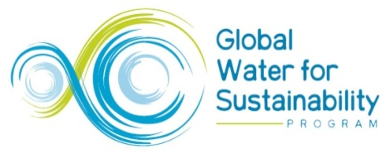
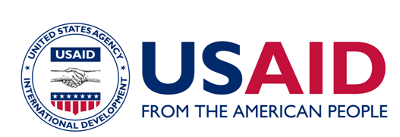

USAID West Africa Water Sanitation and Hygiene Program (USAID WA-WASH)

WA-WASH KM working paper 2
Knowledge Management for WA-WASH and beyond in FY2

Performance Period: October 1st, 2012 – September 30, 2013

Prepared by Jaap Pels, IRC, February 1st, 2013

Reviewed by WA-WASH KM team members
Peter Bury, Victor Otum, Nourou-Dhine Salouka and Tiney Ousmane
and Christelle Pezon

February 2013

Contents
Acronyms and Abbreviations 1
Introduction 2
Reflection on WA-WASH KM in FY1 2
Communication and collaboration 3
KM Deliverables and indicators 5
Connecting KM and CB 6
Moving forward and getting practical 8
Literature, documentation and further reading 9
Annex 1 Outcome mapping, KM-functions and WA-WASH audiences 10
Annex 2 TheBrain, web-based tool documenting and visualizing 12
Annex 3 The WA-WASH KM framework 13
Annex 4 WA-WASH work - plan excerpt 14
Annex 5 WA-WASH –FY1 KM 15
Annex 6 WASH Sector Capacities and WA-WASH Learning 16
Annex 7 WA-WASH Capacity Building Framework 18

Acronyms and Abbreviations
BPD Building Partnerships for Development
CARE Cooperative for Assistance and Relief Everywhere, Inc.
CB Capacity Building
CoP Community of Practice
FIU Florida International University
FY Fiscal year: FY1, FY2
GIS Geographical Information System
GLOWS Global Water for Sustainability Program
IM Information Management
IR Intermediate Result
IRC IRC International Water and Sanitation Centre
I(C)T Information (and Communication) Technology
IWA International Water Association
KM Knowledge Management
LoP Length of Project / Program
M&E Monitoring & Evaluation
NGO Non-Governmental Organization
RAIN Rainwater Harvesting Implementation Network
SKAT Swiss Resource Centre and Consultancies for Development
SNV Stichting Nederlandse Vrijwilligers (Dutch NGO)
Triple-S Sustainable Services at Scale
UNESCO-IHE United Nations Educational Scientific and Cultural Organization-IHE
USAID United States Agency for International Development
USAID/W-AFR United States Agency for International Development / West Africa
WASH Water, Sanitation, and Hygiene
WA-WASH West Africa Water, Sanitation, and Hygiene program
WP Working paper

Introduction
This working paper (WP) is meant to align WA-WASH partner staff in their expectations and thinking on the cross cutting regional component Knowledge Management (KM). As of July 2012 a KM team responsible for the WA-WASH KM agenda – “Knowledge Management for WA-WASH and beyond” see Working paper WA-WASH KM 1 - is installed and operational. Agreements have been made within the KM team how to use information technology (IT)-tools for communication and collaboration within the KM team. Now is the moment to expand the KM-approach and use of these tools WA-WASH wider and include / connect partners to support their WA-WASH efforts.

During the July 2012 WA-WASH CB-forum and the WA-WASH partner meetings July and November 2012 partners expressed the need for support by the KM team to keep track of basic information on ‘what, where and when’ in respect to WA-WASH activities. Right from the July 2012 KM kick-off training workshop the KM team anticipated on this need and developed skills on the necessary tools. The Capacity Building (CB) framework encompasses KM team support in the ‘why and how’.

The chosen / developed WA-WASH KM framework / approach and IT-tools to use are described and it is explained how they will support the KM and CB activities in fiscal year two (FY2: October 2012 - September 2013). The KM and CB approach and thinking complement organically.

This WP has annexes to support the lines of thinking and make clear where the ideas around KM and the WA-WASH KM framework connect with communication, capacity building, networking and the country WASH sectors at large.

Annex 1 describes what is understood by outcome mapping and how that relates to various WA-WASH audiences. In annex 2 the software package by TheBrain - a web-based tool for documenting and visualizing - is discussed and links are given to where it currently within WA-WASH is and can be used. Annex 3 elaborates deeper on the WA-WASH KM framework and in annex 4 and 5 the WA-WASH work - plan excerpt and WA-WASH –FY1 KM activities are recapitulated.

How WASH sector capacities will be enhanced through WA-WASH learning is described in annex 6 and annex 7 shows how the CB framework helps to address three successive issues: ‘Learning, Leverage and Legacy’. This working paper shows how KM will contribute here.

This working paper builds on KM WP1 and various CB documents. It starts by looking back and reflects on KM in FY1 and elaborates on WA-WASH communication and collaboration. A short sidestep is made to the deliverables and indicators for KM, to continue with a narrative on how KM and CB are connected to end with a practical way forward.

Reflection on WA-WASH KM in FY1
Looking back, the KM team had a bumpy start in 2012. First IRC – the lead for WA-WASH KM - had to assemble the KM team and find good replacements for Eau Vive on the ground staff in Niger and Mali and get in synchronization and work as a team. Fortunately IRC could liaise with SNV Niger and SNV Mali to complement the KM team. The training workshop of the KM team in July 2012 laid a thorough basis for the WA-WASH KM work in the next years.

Seydou Traore, the GLOWS / WA-WASH / KM liaison at the Florida International University (FIU) Regional Office (FIU RO) in Burkina Faso is charged to connect more regularly with the KM team since October 2012. GLOWS (GLObal Waters for Sustainability) is the umbrella program WA-WASH resorts under. More info on GLOWS on the GLOWS website: http://www.globalwaters.net.

Unfortunately the Mali activities are on hold because of USAid safety regulations and the security situation in Mali. The report of the KM kick off training workshop and other WA-WSH KM documentation can be found on-line at: http://goo.gl/o8nS7. Also the KM working paper #1 can be found over there.

All WA-WASH partners – except BPD, IWA and IRC’s with Triple-S in Burkina Faso - just started activities as of August 2012. This is actually an advantage because the KM team had time to build its capacity and develop and test its KM tools and channels plus ways to work together closely in different geographical and time zones. Partners are stepping up activities at the end of 2012, so the KM team can now move on to the in-country KM tasks and start collaborating with all partners at country and regional level to document, collect, disseminate, share (the KM framework loop) and learn together. The country coordinator in Ghana (Ernest Tedam) started in July 2012 and the coordinators for Burkina Faso and Niger are to be recruited soonest.

Jaap Pels (IRC) is involved in the GLOWS portal development which is managed by and from FIU Miami. This portal is meant to support WA-WASH information management (IM) and encompass a geographical information system (GIS). It is expected the system will be operational in FY2 and the KM team will be trained to use and operate it. Anticipating the GLOWS portal the KM team works with WordPress blogs which are hosted by FIU Miami. In due time these blogs – one per WA-WASH country - will be integrated. Blogs can be reached at: http://burkinafaso.globalwaters.net.

Communication and collaboration
The KM team recognizes the crucial role of proper in- and external communication and effective use of communication channels. They have organized themselves in respect to use of information technology (IT) very nicely, first to be better connected within the KM team, second to open communication channels with the WA-WASH regional office in Burkina Faso and third as instruments for information management. Below the IT choices and application is illustrated.

Skype
- Work with a Skype group and turn on Skype whenever in the office / on duty / online.
Make sure the Skype indicator (Free / Busy / Do not disturb etc.) is up to date.
Regular Skype meetings although the connection through Internet is still cumbersome.
Chrome
- Use of Chrome as default browser with only a few add-ins.
Useful add-in: Google URL shortener and Google Translate.
Keeping the number of add ins low makes the browser not to slow down too much.
PS Non-work related / other add-ins can be used with another browser for example with FireFox or IE (Internet Explorer)
Google
- A mixture of personal / business (SNV, Globalwaters and IRC) and Google email accounts.
It is strongly recommended to use the Gmail (mali.wawash@gmail.com, ghana.wawash@gmail.com etc.) accounts for WA-WASH work.
- Use of Gmail accounts for country email, country calendar and WordPress editing.
Also the WebBrain account is based on these country Gmail accounts.
- Google groups for mailing lists for:
WA-WASH internal communication: contribute to wawash@googlegroups.com
About the group: https://groups.google.com/forum/wawash
KM team communication: contribute to wawashKM@googlegroups.com
About the group https://groups.google.com/forum/wawashkm
PS Needs review group members.
- Google Drive: https://drive.google.com/
PS Needs constant rationalizing, a manual and a structure
- Use of the more informal WA-WASH KM page on Google+.
Sector calendar / events (where, what and when)
Currently WA-WASH uses three types of calendars:
- Country WA-WASH calendars that can be used and shared for the wider country WASH sector events
- WA-WASH KM team calendar to share with each other: leave, travel, meetings, etc.
- WA-WASH programme calendar showing all relevant WA-WASH programme wide events
- Use Google calendar based on the <country>.wawash@gmail.com accounts.
- Use Google events (in the calendar) to keep visuals / attendance to events together’.
Calendars are linked and displayed in country blogs, example: Burkina Faso calendrier.
Blogs / WordPress
- The main public exposure uses GLOWS WordPress blogs for the country blogs. From here the country calendar, the network map and the other blogs are linked.
  - Burkina Faso: http://burkinafaso.globalwaters.net
  - Ghana: http://ghana.globalwaters.net
  - Mali: http://mali.globalwaters.net
  - Niger: http://niger.globalwaters.net
Sector Map
- We have introduced WebBrain for mapping the country WASH sector, including the WA-WASH programme and its components. This will make it very easy to add concepts / thoughts (organizations, platforms etc, see also annex 2) and publish them directly online.
The mind-maps are linked and displayed in the country blogs (see above). Also other organizations can embed or link to these Mind-Maps in their own webpages (website, list, blog, etc.). See the Ghana Webbrain example at: http://goo.gl/YmiIj.
Coaching / mentoring
How to go about networking (non IT issues) and smart use of IT is part and parcel of mentoring and coaching by the WA-WASH KM team at IRC the Netherlands. In principle Peter Bury is mentoring / coaching Tiney Ousmane (Niger) and Denséni Kone (Mali) and Jaap Pels works together with Victor Otum (Ghana) and Nouroudine Salouka (Burkina Faso).

Recently Seydou Traore of the FIU regional office joined the KM team when possible and Peter Bury can coach on demand. Coaching and mentoring is not only about technical and / or system issues. It is far and foremost about how to make WA-WASH information flow, how to facilitate learning and sharing, how to research the sector, how to keep track of contacts and disseminate information in multiple channels. In that process IT does play an important role. It related to the bottom red box in the KM framework.

The internal communication within the KM team is improving. The July 2012 one week training and the week working together on the Capacity Building forum did the team good in terms of team-building, using IT and learning. In November 2012 Peter Bury visited Tiney Ousmane in Niger to support. The KM team is standard online when connected to the Internet. Regular meetings and short updates keep the team current.

It was anticipated that the GLOWS portal IT system would be ready in July 2012 for training the KM team in using that IT systems to archive WA-WASH outputs (information). Reality is that this training is planned now for March 2013 and expected is July 2013. Practically this means we will have a backlog by then if and when WA-WASH partners start activities. This lack of online repository of WA-WASH relevant documentation is partly filled by the current Google Drive solution to make these documents available.

KM Deliverables and indicators
The three KM deliverables mentioned in the WA-WASH work-plan (See also annual report FY1) are:
- Report on the process used to document, advocate and disseminate WASH lessons learned;
- Creation of a WASH social network and a central document / information repository, and;
- Report on the institutions and resources available which deal with KS and IM in the region.
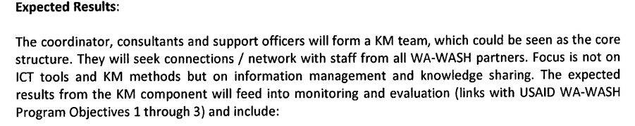
Annotations to deliverables:
- The first is a sort of pre-communication strategy. For this the KM team works with the ideas on outcome mapping. See annex 1. Activities, outputs, impacts etc and link the target groups there. The further integration of KM and CB help a lot to achieve this deliverable. Within CB widening circles of target groups (WA-WASH partners, partner partners, platforms and the WASH sector at large / country scale) are addressed.
- The second deliverable is now supported by the mailing list but it needs better tools and better populating by WA-WASH staff and others in the West African WASH sector. Language remains an obstacle for smooth cross country sharing of information and knowledge. The network and repository function should be split up better. The KM team will more pro-actively encourage partners to use Google Translate to convert text / messages into own language. Also combining CB and KM will contribute to increasing the size of the WASH social network; through CB the country KMteam member gets access to in country WASH staff.
- The last is in fact a living document on the situation in a WA-WASH country and has become more important given the conclusions of the capacity building forum that CB will seek the in-country learning and sharing platforms. For this the KM team would like to work with a WebBrain (See annex 2; WebBrain is a web version of TheBrain) to keep the evolving sector mapped with an easy overview.
In the below table various ‘KM-yard-sticks’ are set together. Focus on FY2 will be on indicator 33 and 34. This WP will count for indicator 33 and cooperation with CB as indicator 34.
Table 1 KM objective and indicators.
Objective 4: Strengthen national and regional enabling environment and capacity to achieve WASH MDGs in West Africa
Name of Activity | Implementing Partner Organizations |  | Type of Instrument
Activity 4.3 - Regional WASH Knowledge Management / Monitoring and Evaluation | IRC and FIU | Count integrated WASH KM products  People joining regional integrated WASH CoP  Integrated WASH KM or networking events organized

Indicator nr | Indicators
IN.30. | Number of integrated WASH networking or cooperating events organized
IN.33. | Number of integrated WASH KM products developed and disseminated
IN.34. | Number of people joining regional integrated WASH community of practice

Inter-mediate Results | Sub-Inter-mediate Results | Indicator nr | Sub-IR Related Outcomes (LoP) | Year 1 Target | Year 1 Achieve-ment | Year 2 | Year 3 | Year 4
 |  |  |  |  |  | Target | Target | Target
WA-WASH all countries
IR.D. | D.2 | 30 | 3 | 1 | 1 * |  | 1 | 1
IR.D. | D.2 | 33 | 5 | 1 | 1 ** | 1 | 1 | 1
IR.D. | D.2 | 34 | 50 | 10 | 20+ | 10 | 10 | 20
* KM kick-off training workshop and facilitating the CB forum
** Working paper KM 1

The above deliverables, the indicator sheet and the activities as mentioned in the annex 3 and 4 need to be taken into account for the planning of activities and deliverables FY2 of WA-WASH. Below is described how these activities and deliverables will be supported by the KM team members and information technology.

The ultimate KM-goal is to leave behind A) practical information on WA-WASH successes, B) a connected network of people in the West African WASH sector and C) an up-to-date overview of the WASH sector in the WA-WASH countries.

Connecting KM and CB
In the project proposal and the work-plan a framework for KM has been presented as depicted in the below left of picture 1. The right picture represents the WA-WASH capacity building. The framed red box top represents a network or group(s) of people busy on WA-WASH activities. CB is such an activity. This group can be people within a WA-WASH partner organization, or a WA-WASH partner staff with local implementer staff, or a learning and sharing platform / working group, or some WA-WASH partners staff together or WA-WASH people with non-WA-WASH people. The crux is that within this group of people learning happens through dialogue and or activities.

Documentation (arrows pointing downwards in the left picture) of these dialogues / activities – of the process – will result in information captured in the lower red box from where the information can be communicated (upwards pointing arrows) to (other) groups of people for learning.

To the right the WA-WASH Capacity Building (CB) framework is depicted. The concentric circles concern the same as the top red box in the left. In fact the right picture encompasses three consecutive / concurrent loops of the left picture. In picture 2, the right of picture 1 is inserted into the top red box of the left of picture 1.

In the first loop (smallest circle ‘Learning’) learning is about capacities of the WA-WASH partners. Part of this loop is skills in KM thinking and use of tools. In the second loop learning’s are leveraged / shared with WA-WASH partner implementers and close allies, but also the in-country learning and sharing platforms, and in the third loop the whole WASH sector is addressed. The thinking is that a WA-WASH legacy builds on WA-WASH learning and leverage by WA-WASH partners.

Picture 1 WA-WASH Knowledge Management and Capacity Building framework
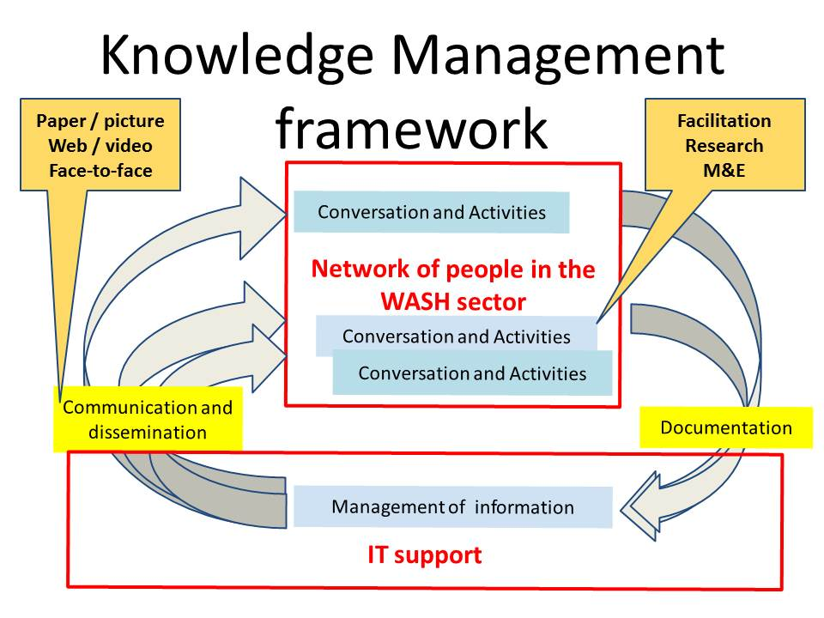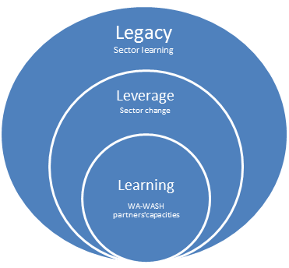

Picture 2 Knowledge Management approach to Capacity Building
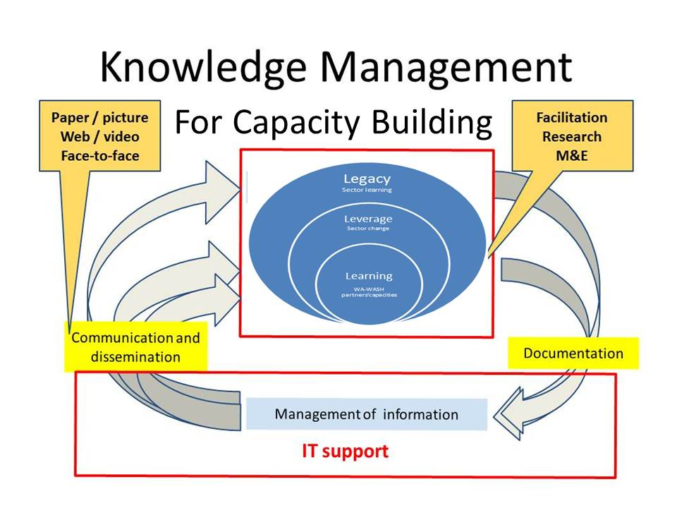

For all three stages of the CB the KM loops must be closed. The key pieces of basic information to collect and to make available to people involved plus the wider audience for every loop are:
- Why; which will be sequential ‘learning’, ‘leverage’ and ‘legacy’,
- Who; people, platforms and organizations involved and later on connected by a WA-WASH mailing groups / social network,
- When; dates of the CB event collected in the WA-WASH calendar,
- What; the topic collected and recorded as WA-WASH information,
- How; most probably given the context and people involved by face to face meetings.

The key IT-tools are described in the chapter ‘Communication and collaboration’ below. When possible WASH staff involved should have access to Internet and at a minimum an email address. To take part in social networks and use most IT tools an email address is needed.

Next to documentation of the above basic information three simple methods can be used to collect a record of the capacities build on the specific WASH topic:

- A round of ‘take-homes’ where every participant mentions at least one and a maximum of three issues she or he has learned from the CB event.
- An ‘After Action Review’ (AAR) session to capture more in detail what has been learned from the CB activity. See for a description of AAR: http://goo.gl/d3lbW.
- Ask participants how they will take the learning’s forward in their own organization / work.

To come to grips with a number of quality aspects any KM and / or CB activity should end with a simple evaluation (happy, neutral and sad) of the components and the overall. A good indicator is whether the participants will recommend (yes, no or maybe) the KM / CB interventions to (sector) colleagues. One can solicit one or two recommendation for improvement of the activity.

To spice up documentation mini-interviews (3 to 5 minutes) with participants and a stream of pictures can be made and send to participants afterwards. Example: http://goo.gl/lfXLY.

The last sentence of the FY1 annual report says: “During the first quarter of year 2 [which is October - December 2012], the KM team will be focusing on reviewing planning and deliverables and ways forward”. Because of the close relationships of KM and communication this paper serves also as input for a WA-WASH communication strategy.

Moving forward and getting practical
The essence of the deliverables is that the country KM team member networks in his own country WASH sector. The support tools are available to keep track of the networking e.g. a list of platforms, organizations (TheBrain), of people (TheBrain / LinkedIn), of activities (Google calendar), WA-WASH partners, pictures, video, blog post etc. It is recognized that in every WA-WASH country, the WA-WASH program covers a subset of organizations working on WASH. A KM team member should have / develop / hone a capacity combination of researcher, reporter and facilitator. The IRC NL team is to coach / mentor.

The prime effort for the KM team in FY2 is to make achievements visible by:
- Updating on a continuous basis the sector map (WebBrain)
  - Linking people / organizations LinkedIn / Facebook / Google+ )
  - Linking learning and sharing platforms
  - Uploading key WASH sector documents like strategies
- Make the country teams visible using TheBrain sector map above; organizations / people
- Updating the calendars / events and publish them through the blog
- Blogging weekly
- Collecting networks in LinkedIn / Google+ (and collect them in TheBrain)
- Collecting AAR / documents of activities
To get regular blog postings there is a need for a list of topics to blog about. Meta-topics such as using TheBrain, on learning and sharing, etc. can be done by Peter / Jaap, but prime responsibility must be with the country KM team member. We need a protocol for blogging on WA-WASH events describing other outreach such as twittering about it. The WA-WASH internal contact-list will be cleaned by Seydou who will also pick-up moderating that Google mail list. A third public mailing list will be made to keep in touch with general public. The next mission of IRC staff should encompass working with FIU RO / Seydou on the mailing lists; the links with FIO RO must improve.

The example for Ghana WebBrain includes government, organizations, people, platforms, policies, practices, programs and projects. Links to LinkedIn profiles, Google+ and documents are inserted!

Niger http://webbrain.com/brainpage/brain/12EC1923-4A93-D177-EFC2-41AFBD823F3E
Ghana http://webbrain.com/brainpage/brain/195A8E14-628B-1D81-F06F-AF4008A18A24
Burkina Faso: http://webbrain.com/brainpage/brain/C0292818-D894-F7CA-7AC7-EBAF0C20CD09
Mali: http://webbrain.com/brainpage/brain/841A3169-0945-9D20-FEBE-BF7627B856F3

For an introduction to TheBrain watch the videos at: http://www.thebrain.com/support.

Literature, documentation and further reading
IKM working papers: see http://goo.gl/Le7Lo

WA-WASH Google Drive solution to make documents available.
WA-WASH KM team permanent ToDo list: todolist (Limited access)

The WA-WASH annual report on FY1 on KM paragraph #4.3 at: FY1 report KM (Limited access)

Various: WAWI / Pels / WA-WASH:
- http://www.washdoc.info/docsearch/results?lmt=20&txt=wawi
- http://www.washdoc.info/docsearch/results?lmt=20&txt=WA-WASH
- http://www.washdoc.info/docsearch/results?lmt=20&txt=pels
Dixon on KM for NGOs: http://www.nancydixonblog.com/2012/06/a-knowledge-management-strategy-for-non-profits-working-in-developing-countries.html

Annex 1 Outcome mapping, KM-functions and WA-WASH audiences
Below are two schemes. The first is mainly used to illustrate the difference between outcomes and outputs but is also typifies a number of audiences and relates them to spheres that differ in outreach; the further away the more difficult reaching out to these audiences will be. The lines show the importance of increasing influence by local actors.

The schema is taken from Chipimbi, R. and Hearn, S.: Outcome Mapping. Bringing learning into development programmes, 15.-18. September 2009 Cape Town South Africa, See online under Hearn PowerPoint presentation for more details on outcome mapping.

Picture 1A Outcome mapping
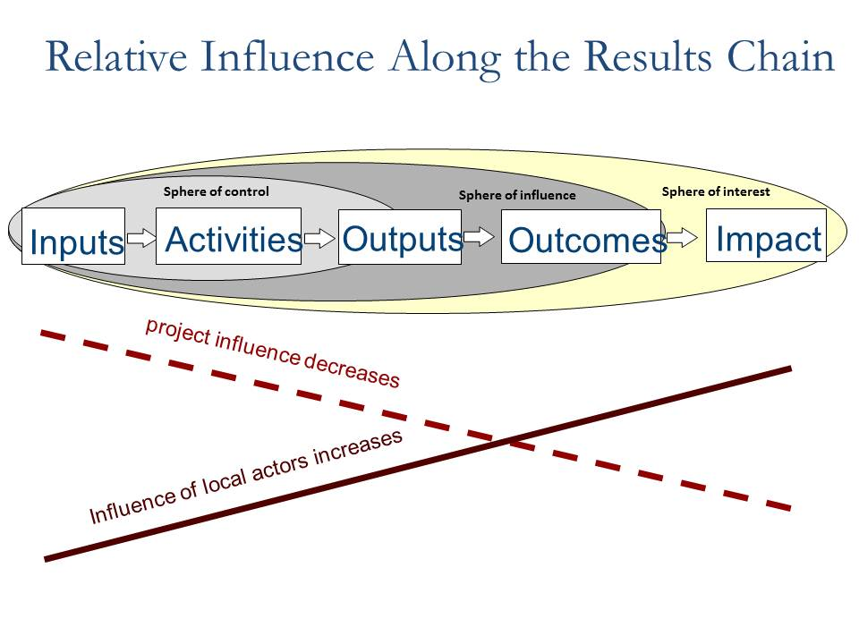

The second picture (Knowledge Management: KStar_ConceptPaper_FINAL_Oct29_WEB.pdf) tells about the role of knowledge management (KM) staff. It also gives an incremental and sequential (from left to right) view on roles and activities. Within the WA-WASH partnership we mostly will be in the sphere of control and act as a knowledge broker; for the sphere of interest the KM team facilitates the access to information from one or more sources.

Picture 1B Kstar infographic
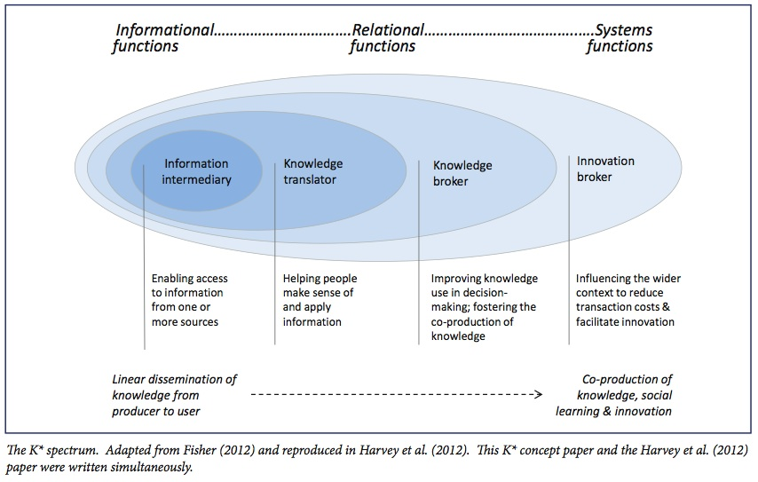

In respect to WA-WASH the KM team realized – given the WA-WASH program developments / progress state-of-affairs, but also given the in country on the ground situation in the WASH sector – to be modest about the position on the above two presented spectra. In fact the KM team needs all attention to operate in the ‘sphere of control’ and as ‘Information intermediary’; both at the left side of the spectrum.

The capacity building (CB) activities offer the opportunity for the KM team to enter the ‘sphere of influence’ and act as ‘knowledge translator / broker’. Outcome mapping teaches that the KM team needs to focus on activities and outputs – which WA-WASH partner does what when where? The Kstar graphic teaches the KM team to focus on its information intermediary function first.

Apart from knowing where to operate in the result chain (picture 1A) and having a feeling on what role to play as KM team (picture 1B), the below table is a first attempt to list WA-WASH audiences.

Table 1A Audiences for WA-WASH
Control /  K-broker | Influence /  Knowledge translator | Interest /  Information intermediary | Remark / URL
WA-WASH KM team |  |  | WA-WASH KM team mail group
 | WA-WASH teams |  | WA-WASH mail group
 |  | Internet public | WA-WASH CoP, Ghana blog,  Niger blog and  Burkina Faso blog
 | WA-WASH FIU RO |  | FIU RO <-> KM team collaboration
 | WA-WASH (partners)
 | Burkina Faso L&S platforms |  | Through the CB activities
 | Other WA-WASH L&S platforms
 | WA-WASH implement partners
 |  | Government
 | Local government
L&S = Learning & Sharing

The proposed activity focus by the KM team fits the above audiences; the sector map (WebBrain) will ‘translate knowledge’ on the sector, the calendars / events help all WASH sector players to see what WA-WASH is doing. Blogging weekly, collecting networks in LinkedIn / Google+ and collecting AAR / documents of activities will concern information to be shared broadly.

Annex 2 TheBrain, web-based tool documenting and visualizing
The Brain is a software package that allows keeping track of digital information of all sorts (called ‘Brains’) on a desktop application. When connected to Internet the Brain can be synchronized with a WebBrain and all embedded links to that instance of the WebBrain will be updated immediate.

Screen dump 2A Ghana WebBrain left (desktop) and right embedded in WordPress blog (browser).
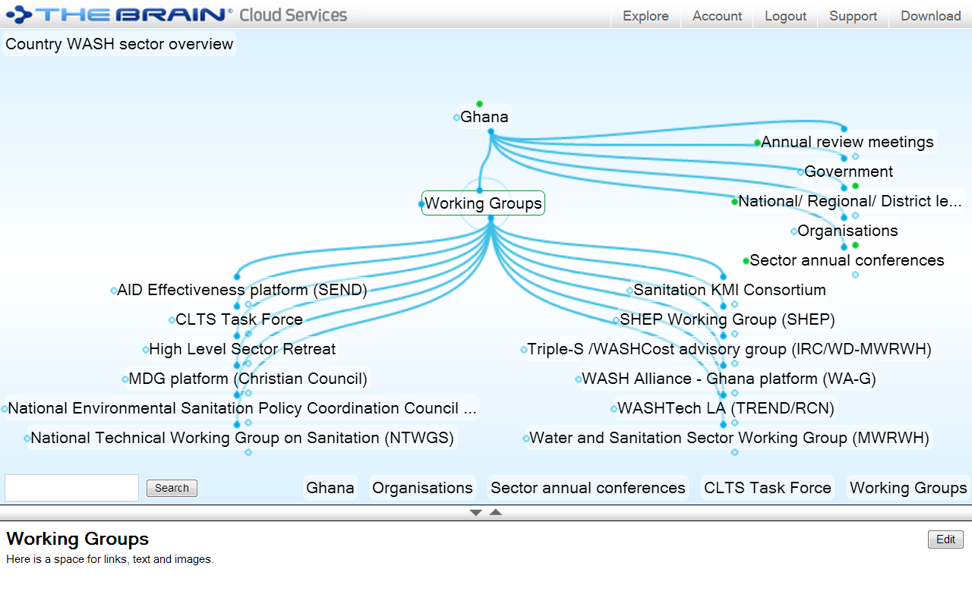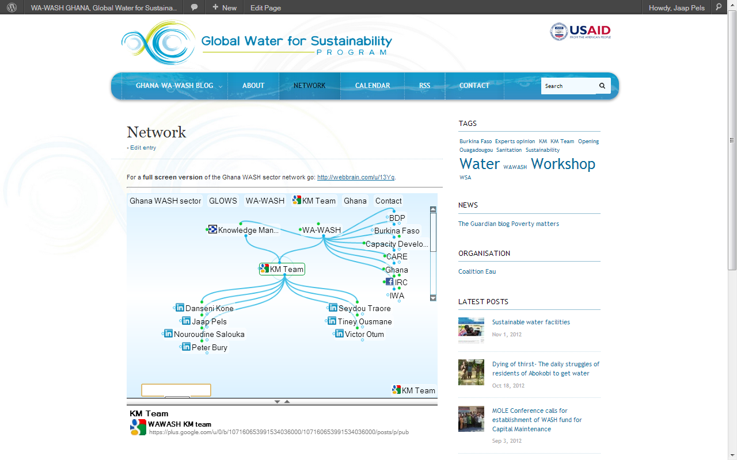

The KM team members will keep track of the WASH sector in their respective WA-WASH country. A basic set-up is made but it is expected that the country Brains will grow over time. Interesting information to keep track of (and link to) is:

- Organizations / People active in WASH (when possible linked to an organization)
- Policies / Practice
- Government / Strategies
- Projects / Programs
- Platforms (for learning and sharing)

These brains / networks can be made in a face to face session with sector experts and reviewed by other sector experts. The fact that is concerns a desk-top application that can be synchronised with the WebBrain version when a connection is available, makes it very suitable for use in West Africa.

It is important to research the (L&S) platforms. These platforms should be assessed on their capacity to absorb WA-WASH learning’s and when needed, they should be capacitated. An example would be to change the character / style of a platform from ‘informing’ to ‘discussing’ or from a ‘press conference’ style to working with break-out groups and / or an open space method.
The people are important to contact / inform by narrowcasting (focused message to small group).

The brain will also serve as a central place to collect to most up-to-date policies.

See http://www.thebrain.com for more details and functionalities.

Annex 3 The WA-WASH KM framework
The KM framework provides a tool to visualize the linkages and fit between knowledge management activities, tools and methods for WA-WASH.

Figure 3A The WA-WASH Knowledge Management framework

- “Conversation and Activities” through which research, Monitoring and Evaluation (M&E), reflection, knowledge sharing, learning and sharing happens,
- “Documentation” of processes used ( minutes, plans, etc.) and lessons learned (briefing notes, videos, stories) to create tangible source of information on what and how such happens,
- “Management of information” to keep all KM information organised and accessible in the longer term (such as website),even after the project finishes,
- “Communication and dissemination” to target audiences in the right format at the right time.

The activities and results proposed within WA-WASH fit the KM framework by providing inputs / activities / results at each component of the framework. A WebBrain and a blog are tools to document and update the networks in the WASH sector. By synchronising the WebBrain will be available for communication and dissemination. A blog is directly available.

Capacity building takes place in the upper red box. The KM team will support with facilitation and tools like a calendar, mailing list etc. See also annex 1 and 2.

Annex 4 WA-WASH work - plan excerpt
The WA-WASH KM component is described in sub-activity 4.3.1 (a)

Sub-Activity 4.3.1: Managing knowledge within WA-WASH and beyond

Geographic area: Regional
Responsible Organization: IRC
Sub-Activity Coordinator: Jaap Pels
The implementation of the WA-WASH program will generate information and knowledge. For better sector performance, this information has to be collected, managed and disseminated, and knowledge has to be shared. Based on the developed framework for knowledge management (KM) processes and the newly set KM team, the focus of implementation year 2 will be as follows:
- Align KM team activities in all countries with partner activities
- Organize where possible field visits and take inventory of WASH country sectors and WA-WASH partners activities
- Collect coordinates (email / location / organization) of sector people and network
- Work with FIU Regional Office / Miami to populate the GLOWS repository (e.g. with reports, databases, etc.), and define jointly the training needs using the repository and how it will be provided
- Continue regular blogging on the WA-WASH country blogs
Apart from the first four activities of year 1 (in the above list), the list of activities for the next years is essentially continuous with minor changes:
- Publish information: WA-WASH lessons learned to be processed and documented into fact sheets, working papers, case studies, news items, etc., and disseminated, as well as used for advocacy purposes. For every audience a product mix will be developed. WA-WASH partners are expected to deliver the products and the KM team can provide coaching / guidance and help with dissemination.
- Manage social network: A social network for WA-WASH involved people operational and running, with a mailing list using: https://groups.google.com/forum/?fromgroups#!forum/wawash.
- Face to Face meetings: At least four WA-WASH face to face meetings organized to document the process and share WA-WASH documentation. The 2012 July CB forum was the first.
- Community of Practice / Practitioners: A self-supportive community of practice that will last beyond WA-WASH is established and fully operational.
- Hand over activities to partners: In-country KM teams (including partner members) established to take ownership of the KM strategy and its implementation, and support FIU for the implementation of the WA-WASH communication strategy.
A new activity will be for the IRC KM staff to be working together with FIU Miami and FIU Burkina Faso staff on the GLOWS portal development. See activities under Annex 5 4.3.1 (b) below.
Deliverables
- Maintenance of a WASH social network based on the Google group (see 3 above) and possibly LinkedIn (www.linkedin.com) and / or Google+ (https://plus.google.com/up/start).

Annex 5 WA-WASH –FY1 KM
Sub-Activity 4.3.1: Managing knowledge within WA-WASH and beyond

Geographic area: Regional
Responsible Organization: IRC
Sub-Activity Coordinator: Jaap Pels

The implementation of WA‐WASH will generate information and knowledge. For better sector performance, this information has to be collected, managed and disseminated, and knowledge has to be shared. A framework for knowledge management (KM) processes has been developed. At start‐up, a professional staff meeting is planned for December 2011 / February 2012 bringing together the IRC KM staff, locally hired KM consultants, partner KM staff and (local) WA‐WASH staff to finalize the strategy, processes and formats to be used and plan activities and outputs. It will also mark the start of the KM team. It is to be expected that the USAID WA-WASH activity planning will need to be updated on a regular basis and it is expected that the Regional USAID WA‐WASH in Ouagadougou will play a major role in KM and communication activities. There are links with communication and monitoring and evaluation, as well as with sustainability aspects of USAID WA-WASH. An amalgam of start-up activities (1 through 6) as listed below is needed to start going concern (7 through 13).

- Hire consultants – preferably from country WASH Resource centers or otherwise IRC partner organizations on a call down contract to document processes, create, store and disseminate information to agreed target groups and facilitate knowledge sharing processes.KM team member.
- Platform selection to store all information on also beyond the life of the USAID WA-WASH project. Candidates are AKVO (www.akvo.org), the FUI – integration with the GLOWS websites will be sought.
- Platform set-up after a selection has been made. This will lead to a document describing agreements, tools and methods, (update) procedures and roles / responsibilities WA-WASH partners, KM and WA_WASH Burkina Faso team members.
- Workshop with WA-WASH office / partners as soon as possible to discuss / agree on the platform selection and set-up as described above. Establish working relations.
- Workshop with KM team as soon as possible to discuss / agree on the platform selection and set up as described above. Establish working relations.
- Publish USAAI WA-WASH KM working paper describing the approach and set-up of KM in WA-WASH.
- Publish docs: WA‐WASH lessons learned processed and documented into fact sheets, working papers, case studies, news items, etc., and disseminated, as well as used to advocacy purposes. For every audience a product mix will be developed.
- Manage repositories: A central repository for WA‐WASH partners and a website for the wider WASH community provided has to be managed.
- Manage social network: A social network for WA‐WASH involved people around the world operational and running, with a mailing list.
- Face to Face meetings: At least four WA-WASH face‐to‐face meetings organized to document the process and share WA-WASH documentation.
- Community of Practice / Practitioners: A self-supportive community of practice that will last beyond WA-WASH established and fully operational.
- Hand over activities to partners: In-country KM teams (including partner members) established to take ownership of the KM and communication strategy and its implementation
- Manage platforms: The ICT must be managed technically and it is expected partners want to connect and integrate content form the USAID WA-WASH repositories into their own systems.

Annex 6 WASH Sector Capacities and WA-WASH Learning
In order to figure out what and where capacities are most needed in Burkina Faso and how to foster learning and sharing in the sector, two assessments have been conducted.

IWA has developed an assessment on HR capacities and gaps to reach MGDs and full coverage by 2015. More specifically, IWA investigated HR capacities in planning, operating and financing WASH services at national and local levels. The main conclusions are that the biggest needs are identified at local level and in the sanitation sub-sector. The shortage is so enormous (needs range from 30 to 40 times more than existing capacities in each category) that all capacity building initiative is most welcome. However none can fully meet the demand within a project timeframe.

WA-WASH capacity building component addresses the most crucial needs identified, notably the development of capacities at decentralised level such as planning and management skills. In size, the contribution of WA-WASH capacity building will highly depend on partners’ ability to leverage their plans and reach sector professionals.

To complement IWA studies, IRC desk-studied the existing sharing and learning platforms and mechanisms at stake in each of the four countries, from which WA-WASH can learn and on which partners can build to leverage capacity building efforts. The main conclusions are:

- There is no such thing as a learning platform or mechanism active at regional level: existing WASH dedicated platforms only exist at country level;
- In all four countries, though better shaped in Ghana and Burkina Faso, there is a number of digital and other platforms, governmental or non-governmental or project led which justifies WA-WASH to invest in existing channels rather than creating new sharing and learning spaces;
- Building on / supporting existing platforms to share / discuss / validate / disseminate WA-WASH capacity building approaches and tools would help WA-WASH to reach capacity building targets;
- Except for governmental led platforms, digital and other platforms suffer from lack of mandate, leadership and sustainability;
- Developing the KM capacities of these platforms would contribute to reinforce sector learning and stand as WA-WASH legacy.

The capacity building forum held in Ouagadougou in July 2012 validated the assessments and helped to design WA-WASH capacity building programme and action plan. See Forum’s report.

All participants at the forum are interested in at least one of the capacities WA-WASH partner will develop, either at communal level (MUS, RWH, SDA), or national level (Climate change) or through partners (CVA). With regards to capacity building at household and community levels, and as potential trainers themselves, sector professionals insist on having contextualised approaches / concepts and simple messages and tools for further replication at household and community levels. A lot has been done in Burkina the last decades. The sector and WA-WASH partners should learn from each other’s knowledge and expertise.

Face to face meetings are favoured as well as established platforms to allow WA-WASH partners to share / expose / discuss the capacities they seek to develop / reinforce to sector professionals in position to adapt / replicate / improve / transfer those capacities into other communities and communes. The table below gives an overview on each partner’s targeted capacities and beneficiaries.
Table 6A Partners’ CB plans: capacities developed and direct beneficiaries
Beneficiaries  WA-WASH Partner | Household | Community / Village | Local / Commune | National | Partners
BPD |  |  |  | Partnerships Training Workshops*
CARE |  |  |  |  | Training sessions  - WASH Financing  - Gender Analysis  - Vulnerability/Adaptation to Climate change
FIU | Workshop  Hygiene and water storage behaviour | Radio campaign  Mobilisation on point of use treatment |  | Conference**  - Food security  - Peri-urban W&Ss  Working group climate change | Research capacity  Pool of MSc interns and PhD students
UNESCO-IHE |  |  |  | University students WASH module(s)
IRC |  | Workshops and coaching  - Planning water services  - Monitoring service levels/costs  - Scaling-up support functions to improve sustainability |  | Learning & sharing platforms (GOG & donors, NGOs) | Workshops and NGO platform open to partners
RAIN | Workshops Retention, recharge and reuse |  |  |  | Workshops open to partners
SKAT | Workshops Self supply |  |  |  | Workshops open to partners
WaterAid | Workshops Community Led Total Sanitation |  |  |  | Workshops open to partners
WinRock |  | Workshops  - Planning water needs  - Manage procurement/contract  - Design low cost technology  - MUS approach* |  |  | Workshops open to partners
* Delivered before October 1, 2012.
** Two regional conferences on Climate Change are planned Yr2 and Yr4, one possibly organised in Burkina Faso.

Annex 7 WA-WASH Capacity Building Framework

The CB framework should help to address three successive issues: Learning, Leverage and Legacy.

Figure 7A The spheres of WA-WASH Capacity Building

The thinking is to work in overlapping spheres, where WA-WASH starts with building the capacities of the partners. This is the sphere WA-WASH has ‘control’ over learning through capacity building. Second, capacity building reaches out for the sphere of influence, where capacity building by WA-WASH aims for leveraging changes in the WASH sector. Ultimate goal is to enter the sphere of interest; where WA-WASH wants to build a legacy.
Learning
All partners can participate to any WA-WASH conference, workshops, seminars, etc organised by a member of the consortium. All partners will make their material available to and inform the others about their capacity building interventions via the KM team. All partners will document their capacity building activities and make it available to other partners via the KM team.

When / if partners agree, these materials and documentation can be disseminated through the digital platforms IRC administrates in Burkina Faso (blogs, calendar and mailing list). This is to be coordinated with the KM team. Exchange visits of WA-WASH partners from one country to the others can also help cross-fertilise experiences and increase internal capacities.
Leverage
In order to increase internal WA-WASH capacities by learning from each other and to leverage the primary audience to sector professionals which can further improve and replicate approaches and tools countrywide, it is proposed to use existing platforms and channels.

In particular, and as the coordinator for capacity building at decentralised level, IRC can facilitate quarterly thematic meetings centred on local governance (Maîtrise d’ouvrage communale). These meetings will be hosted by an existing platform (Groupe d’échange des ONG), documented by the KM officer and relayed through existing digital media (blogs, faso.net, WA-WASH mailing list etc).

Initially limited to the NGOs supported by the EU, the Groupe d’Echange also counts representatives from donors and water and sanitation departments. With the inclusion of USAid supported NGOs, this Groupe d’échange would gather the main implementers of the WASH sector in Burkina Faso, thus be a good vehicle to maximise indirect beneficiaries and favour the uptake of WA-WASH concepts/approaches/tools by sector professionals (sector change).

To be addressed is the position of the working group on climate change to be set up by FIU in Burkina Faso vis-à-vis this platform.
Legacy
WA-WASH capacity building legacy consists in the development and integration of WASH modules in training institute curricula and the development of KM capacities of the learning and sharing platforms (sector learning). The network of people and the mailing list will help again here too.
Resources
IRC, 2012, Report on the WA-WASH Capacity Building forum 2012, July 16 – 18, Ouagadougou
IRC, 2012, WA-WASH Capacity Building Framework Burkina Faso, December 2012
IRC, 2012, WA-WASH Working paper 1 on Knowledge Management, March 2012
IWA, 2012, Report on assessment capacities WA-WASH countries, September 2012
UNESCO-IHE, 2012, Adapted work-plan

Peter Bury and Christelle Pezon IRC the Netherlands | Victor Otum IRC Ghana | Nourou-Dhine Salouka IRC Burkina Faso | Tiney Ousmane SNV Niger
The WA-WASH KM team deliberately points contacts to social networks like LinkedIn, Facebook and Google+ with the ‘Legacy aim’. The connection WASH staff in West Africa makes with these social networks will stay after WA-WASH is over (WA-WASH and beyond). Also it appeals to people’s behaviour to make themselves known and ‘find-able’ for other WASH sector staff.

