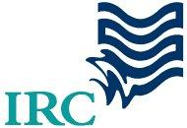


Project Brief – January 2009-version
Improved WASH Governance in West Nile through Local Dialogue
NETWAS Uganda
A project funded by the European Union

Improved WASH Governance in West Nile through Local Dialogue

Supporting the water, sanitation & hygiene (WASH) sector to perform better

Local Governance in WASH
This initiative will contribute to further improve WASH Governance by local multi-stakeholder dialogues and actions towards water consumers, communities and schools. The dialogues are directly linked to the District Water and Sanitation Coordinating Committee and the sub-county committees.
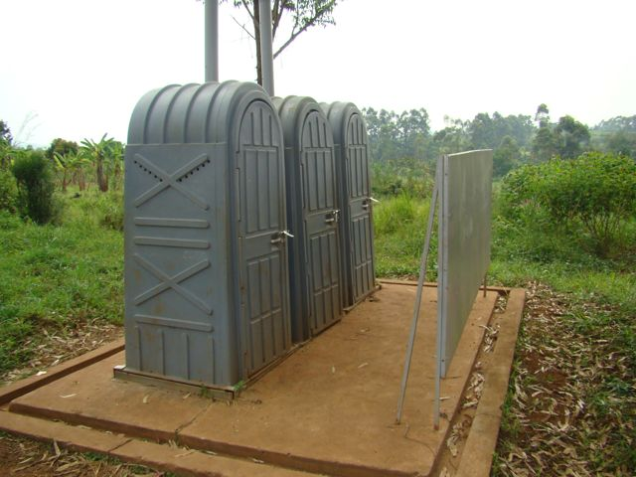
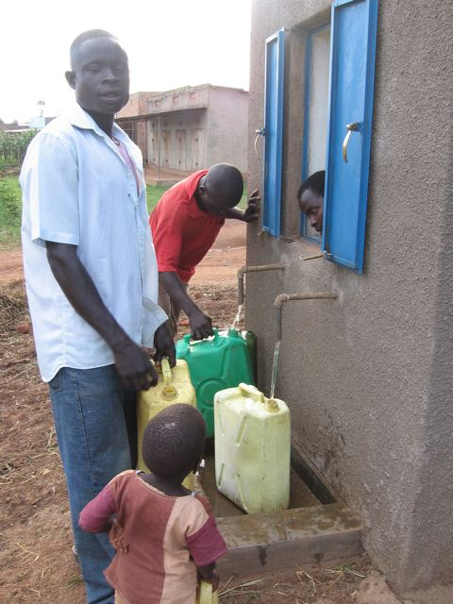
Where sectors develop, cost recovery is introduced, and then the demand for better service provision emerges. Consumers are paying for water and in return want good services. Payers-for-services expect communication from the water managers. For instance, they want to know what actions are planned to address their concerns, in what timeframe and with what financial implications. Or communities contribute financially and otherwise to improving their self-managed WASH services; and they expect or solicit support from local government and NGOs. In a context of scarce resources, these government and non-government agencies have to make priorities in budget allocations and activities/projects. This leads to many questions at the community side that need to be answered. Monitoring will indicate how the water service providers at district and community level perform. Actually, the challenge is how to keep the consumer relation right, communicate properly and show that the results are good value-for-money. Where no government/NGO action – because of prioritisation in budget allocation - comes after participatory planning, they often fail to communicate with feedback; this may frustrate people.
Sanitation and hygiene (San&Hyg) are content areas shared over several government portfolios: health, education and water. Both government and NGOs have San&Hyg high on their development agenda to improve the health and well being of the people. The household San&Hyg needs are high. Schools demand for better San&Hyg to keep girl absenteeism low and fulfil their objective of setting an example in life skills. But allocating budgets is a complex matter and may result in many get small allocations or a few all. Then actual activities in the communities and primary schools may be limited, or result low budget-effectiveness. Collaboration between NGOs and local government often shows ample room for improvement. This initiative will contribute to improved coordination and increased governance and accountability on the performance and use of limited San&Hyg resources.
Water kiosk Masindi district, photo Jo Smet
School latrines, Kamwenge district; photo Jo Smet
The Ugandan WASH sector has created a conducive coordination mechanism: the District Water and Sanitation Coordinating Committee (DWSCC), where local government and NGOs meet and coordinate. The project will create a direct link to the DWSCC for follow-up.

Dialogue with all stakeholders at district and sub-county
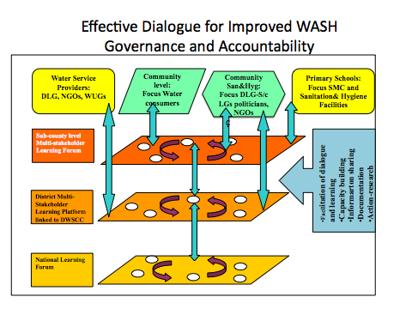
The WASH sector has many stakeholders. They do the households/community initiatives- for-action, the participatory need assessments and planning to the construction and management of services, and support in water service provision. Indeed, households, CBOs, WUGs, private service providers, local leaders and government staff at different levels, and furthermore the councillors at district and sub-county level. Local and national/international supporters include NGOs, government and other donors. They give support towards construction of WASH systems. Perhaps also support to make local management and O&M of systems and services work towards satisfaction of consumers and users and sustainability. This initiative will bring these stakeholders together at district and sub-county level to facilitate dialogue towards better governance and accountability to water consumers and San&Hyg users (households and schools). Process, tools and results will be communicated to the DWSCCs.

Building on present successes and improving for effectiveness
The initative does not start from square one. West Nile region has developed several good processes and tools to improve governance and accountability, to some extent also in WASH sector. The initiative will build on these. And the implementing agencies have experience with supporting local governance (CEFORD in water and education), social accountability (NETWAS), and transparency, accountability and local WASH governance (IRC). Linkages will be made with other local initiatives such as accountability in health sector by districts and CARE. And action-research with new accountability tools and innovative processes are planned to make accountability more feasible and effective.

What will project contribute to WASH governance in West Nile?
This initiative will contribute to improved governance and accountability on water and San&Hyg at district level, sub-county and community level. This will help to increased investment-effectiveness and sustainability of the water service provision. It is expected that planning, budgeting and implementation for promotion household San&Hyg and school San&Hyg implementation will improve. The project will also contribute that communities will demand for more accountability from the stakeholders.

Project area and timeframe
Nebbi, Moyo and Adjumani are the three project districts, in each two sub-counties will be selected. The project is expected to run until October 2010.

More information and contacts
IRC International Water and Sanitation Centre, P.O. Box 40398, Kampala, contact Mr. Jo Smet, smet@irc.nl; http://www.irc.nl/page/46748
NETWAS Uganda, P.O. Box 40223, Kampala, contact Mrs. Cate Nimanya or Mrs. Brenda Achiro, netwasuganda@gmail.com, http://www.watsanuganda.watsan.net
CEFORD, P.O. Box 303, Arua, contact Mrs. Esther Piracel, ceford_ug@yahoo.com, estherpiracel@yahoo.co.uk

CEFORD and NETWAS/IRC will build on WASH capacity development and learning experiences in West Nile Region
CARE has similar project under EDF-SDP in same districts focusing on health (PHC) and education (UPE)

